**Machine Learning**

**Assignment 1: -**

**Example 1:**

1. **Heuristic 1**
   1. **ID3**

Tree: constructed after applying ID3 algorithm on training data set.

Screen shot:

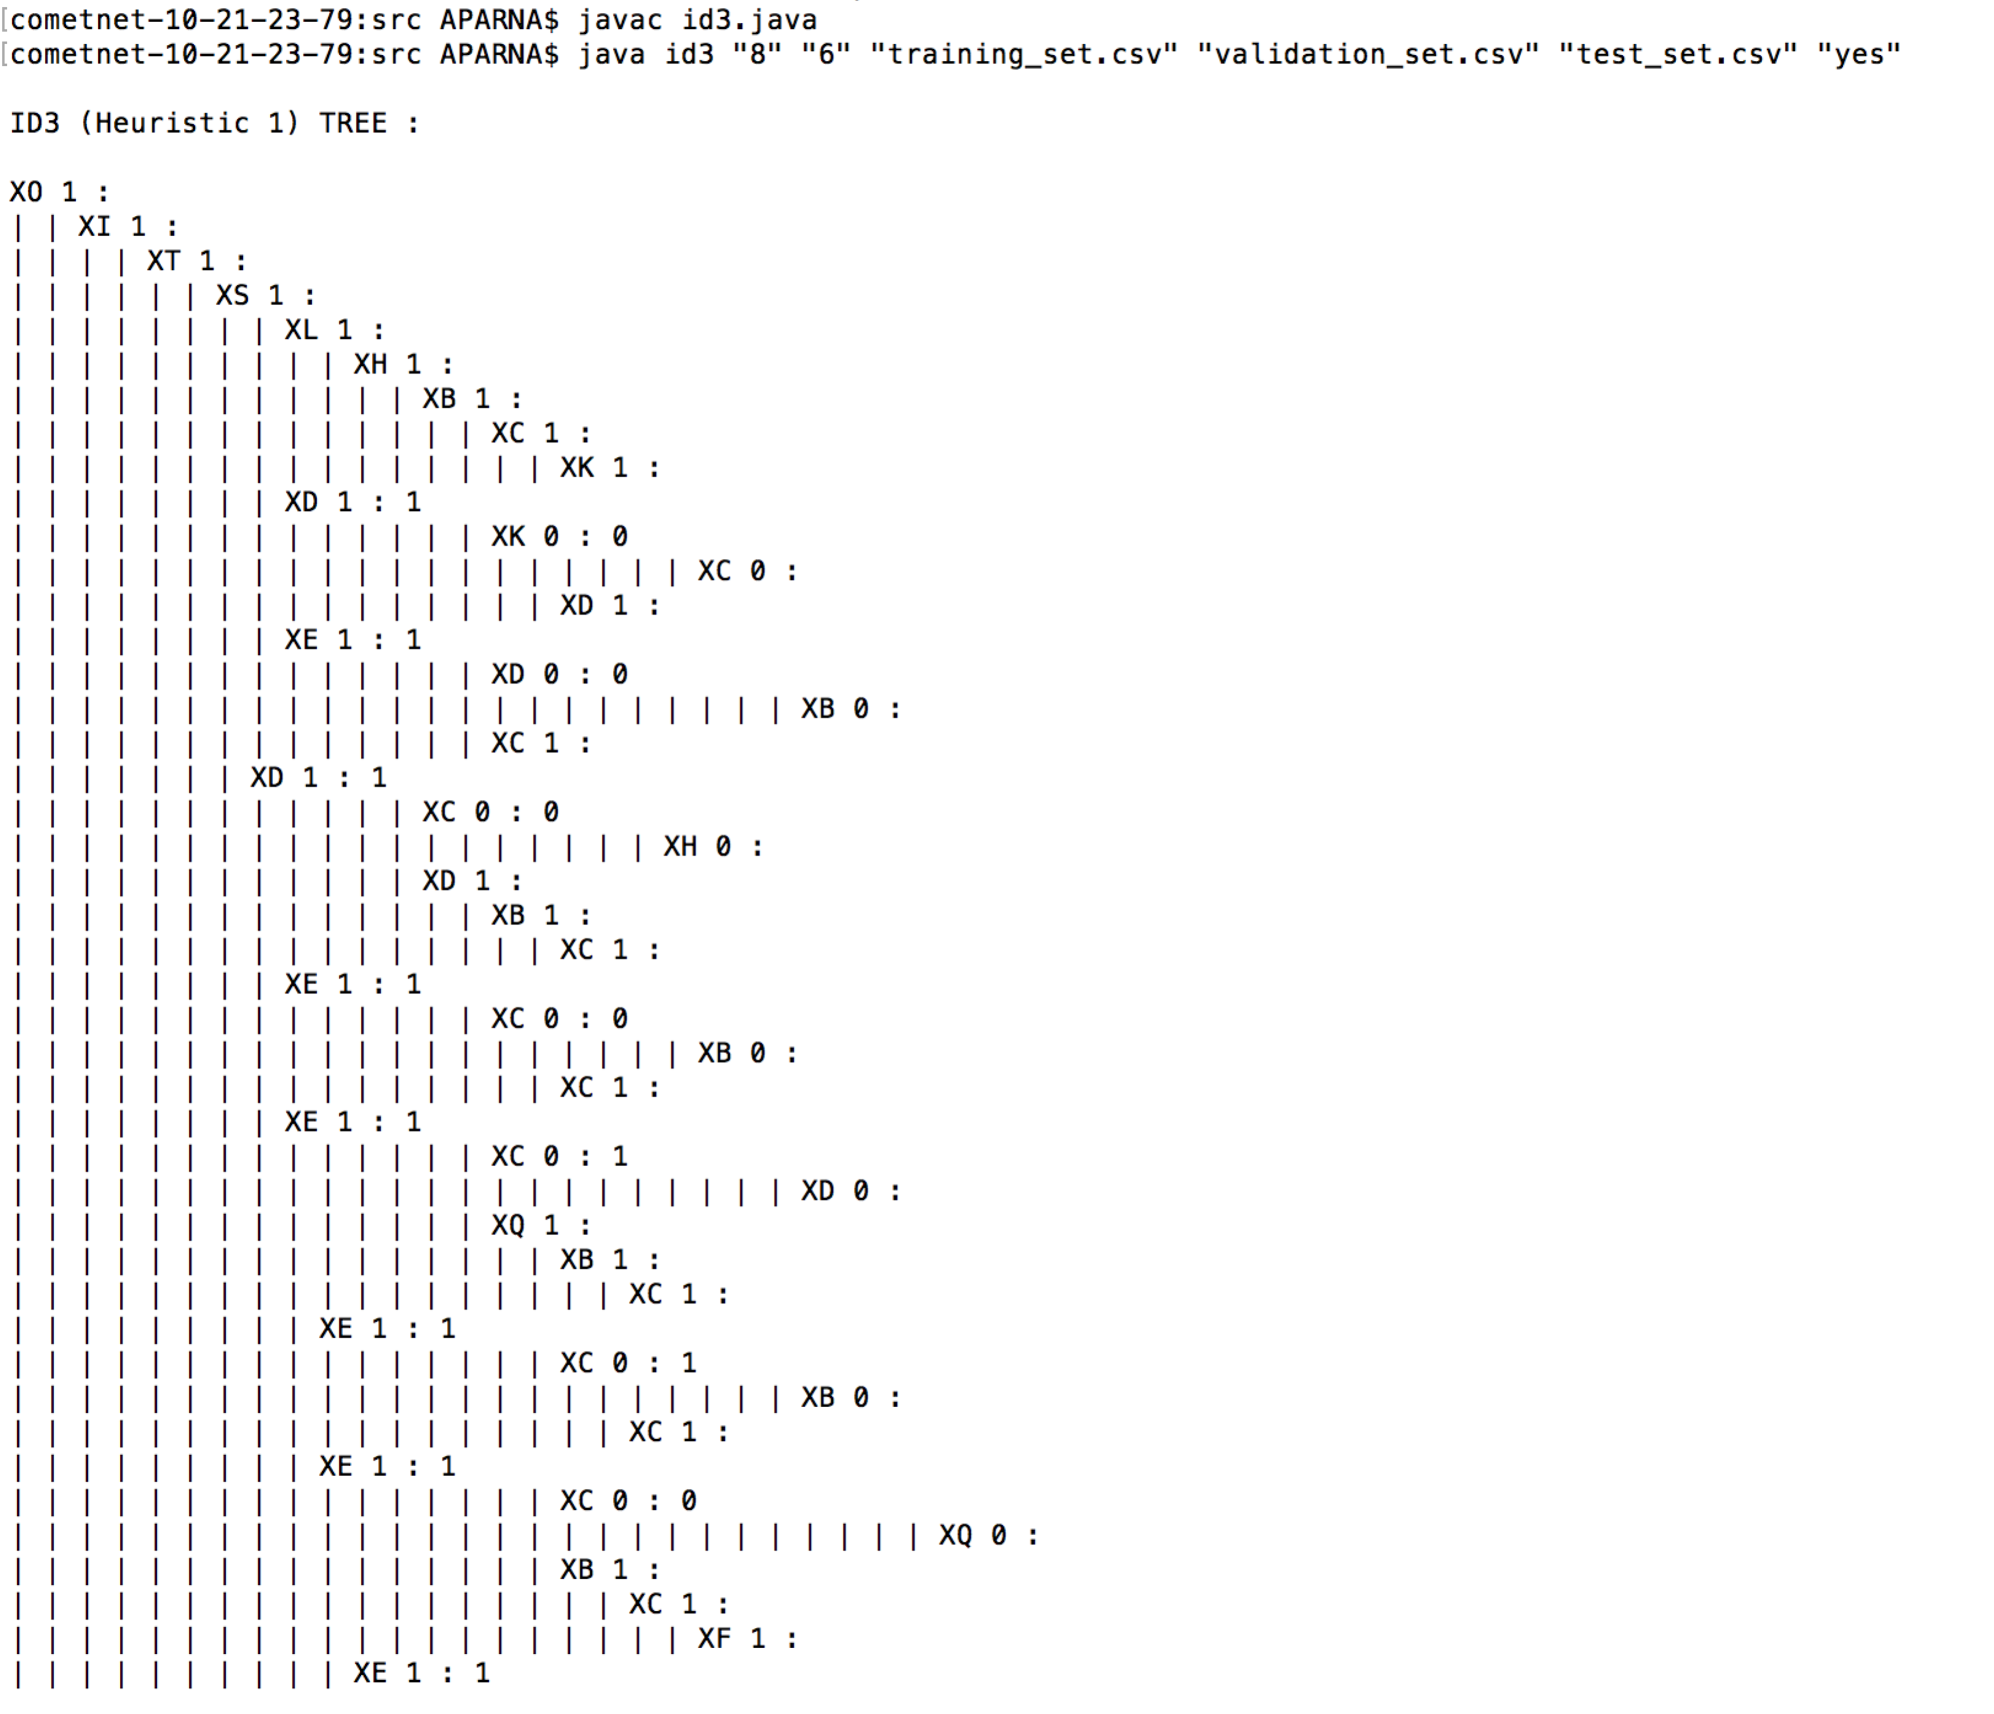

Accuracy: calculated on test data set on the tree, constructed by ID3 algorithm on training data set.

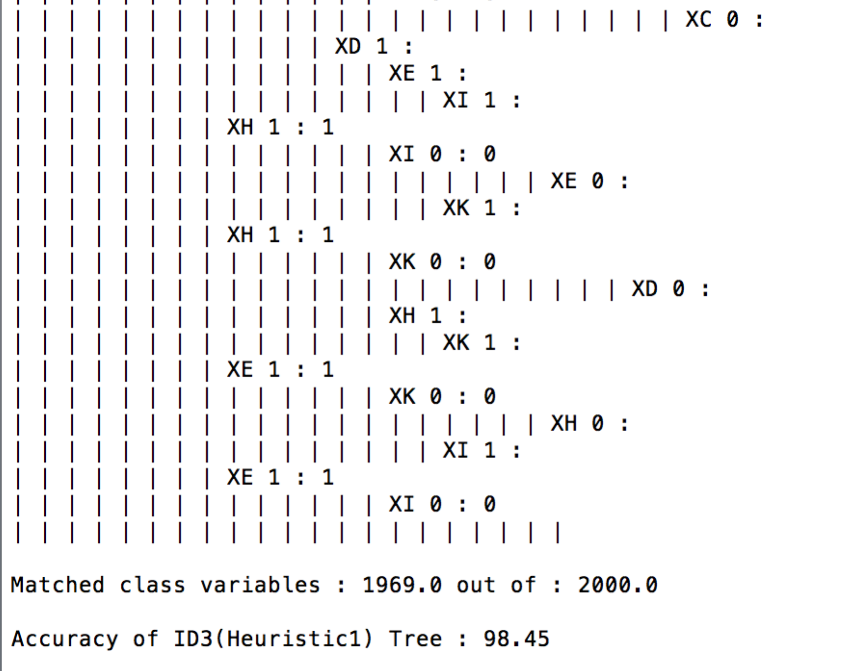

* 1. **Post Pruning**

Tree: Pruned tree on validation data set.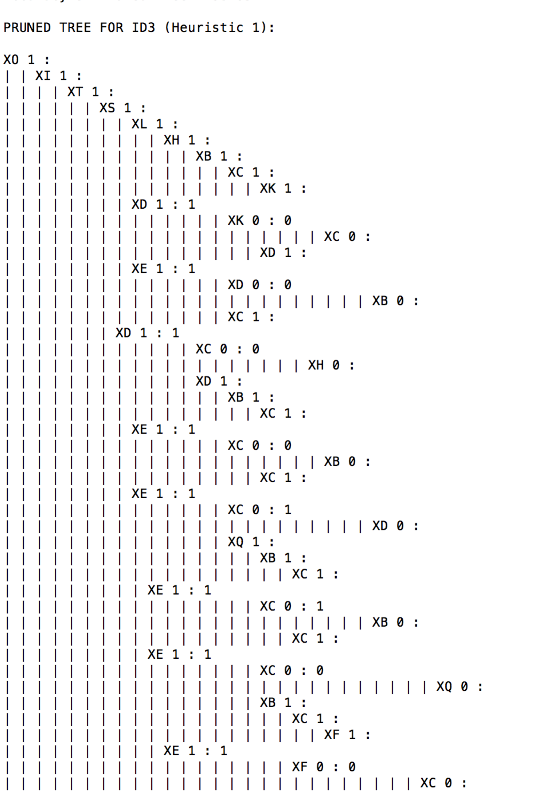

Accuracy: calculated on pruned tree with test data set.

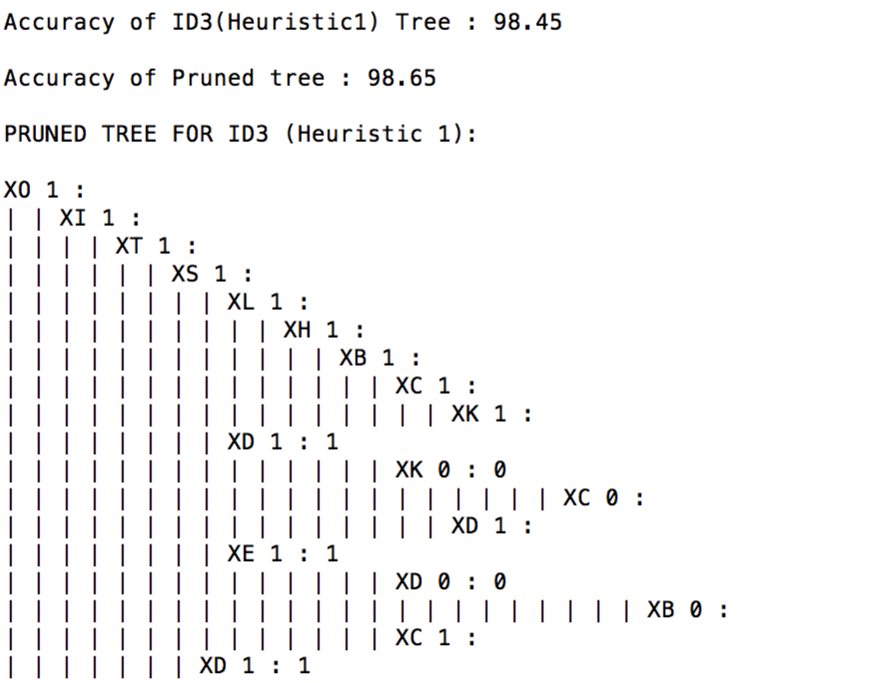

1. **Heuristic 2**
   1. **Algorithm**

Tree: constructed after applying ID3 algorithm on training data set.

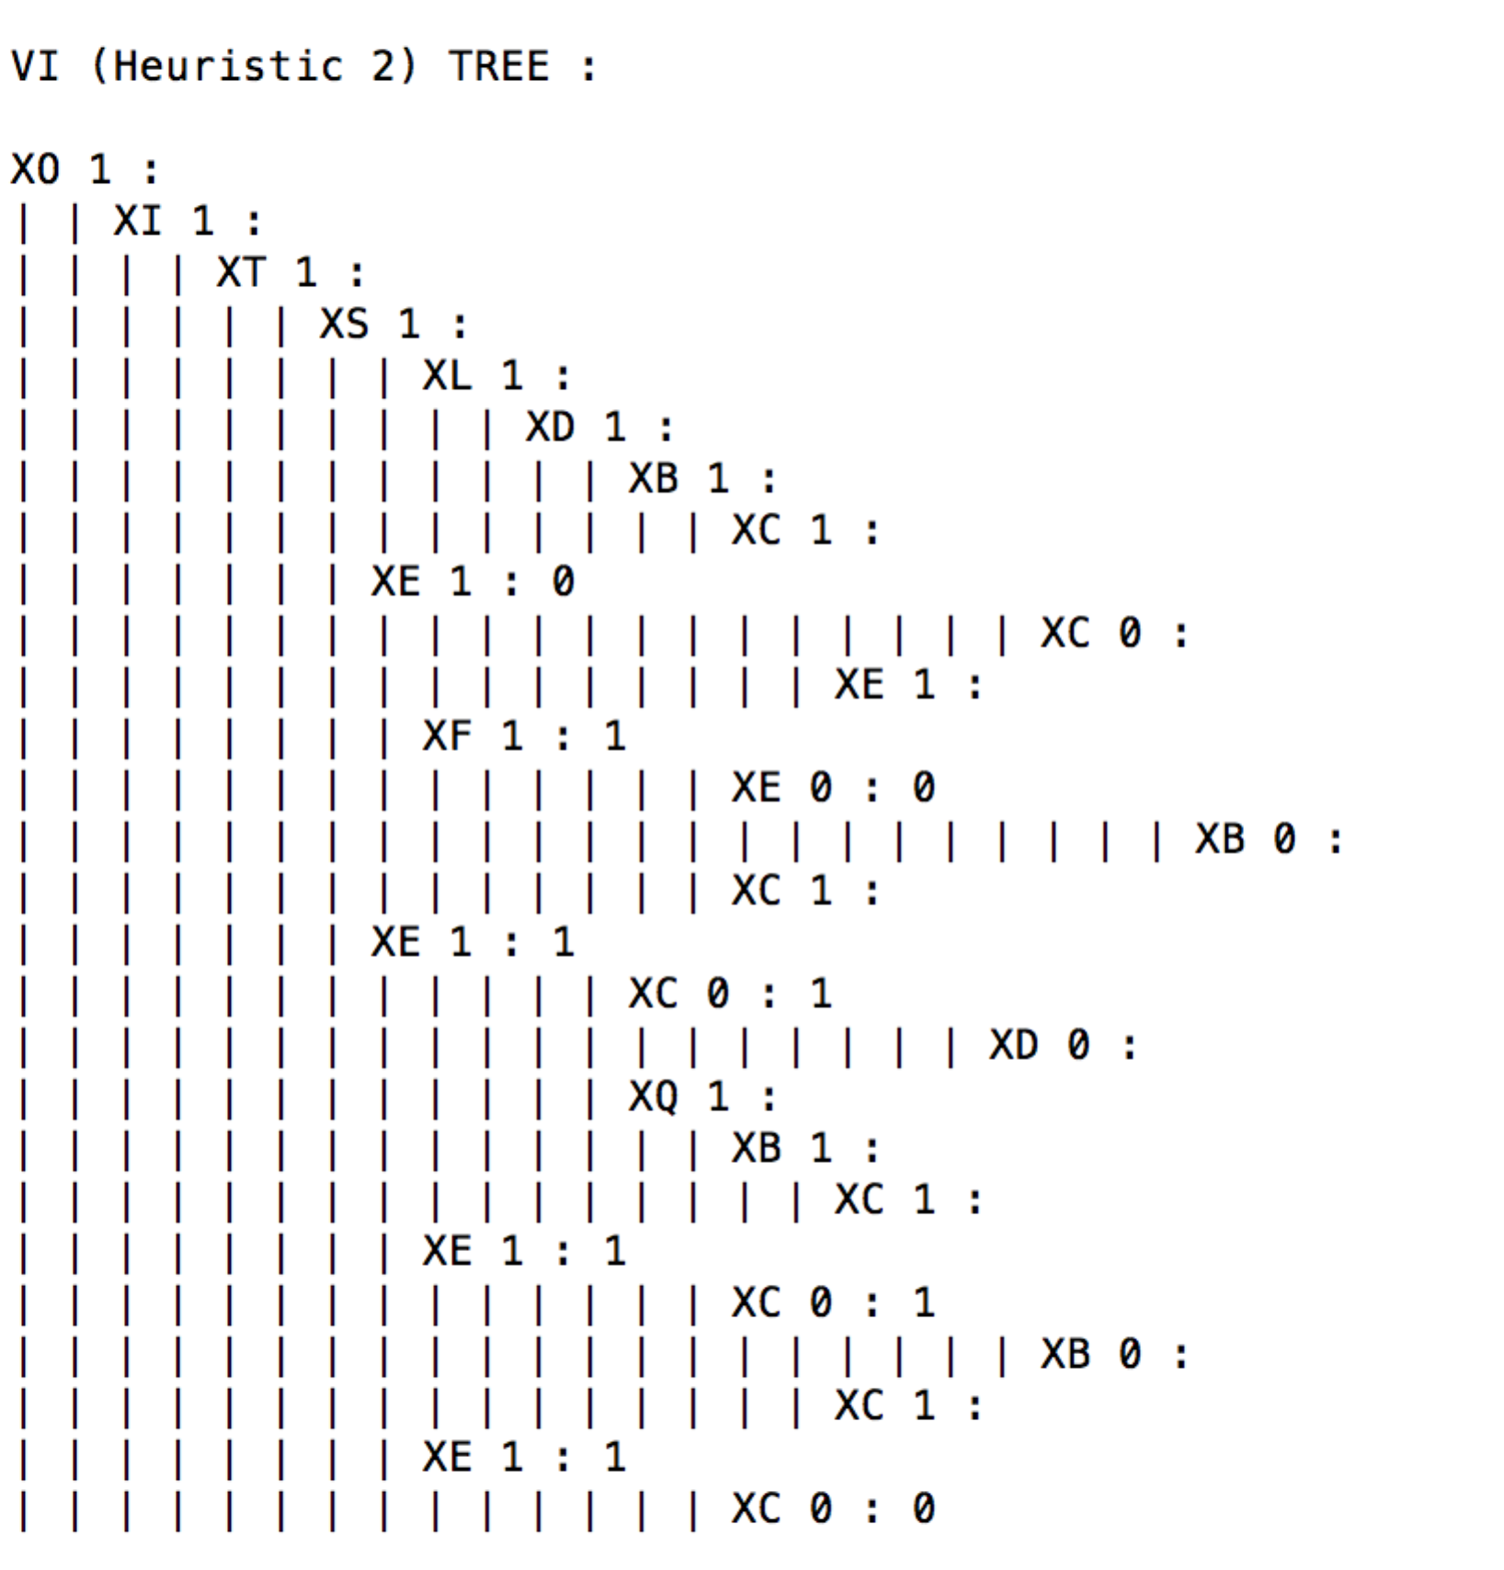

Accuracy: calculated on test data set on the tree, constructed by ID3 algorithm on training data set.

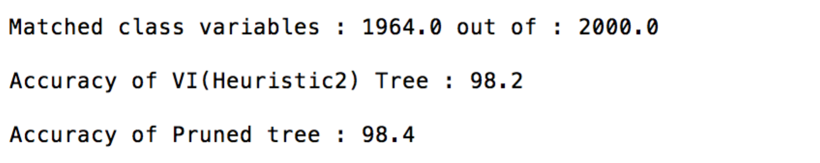

* 1. **Post Pruning**

Tree: Pruned tree on validation data set.

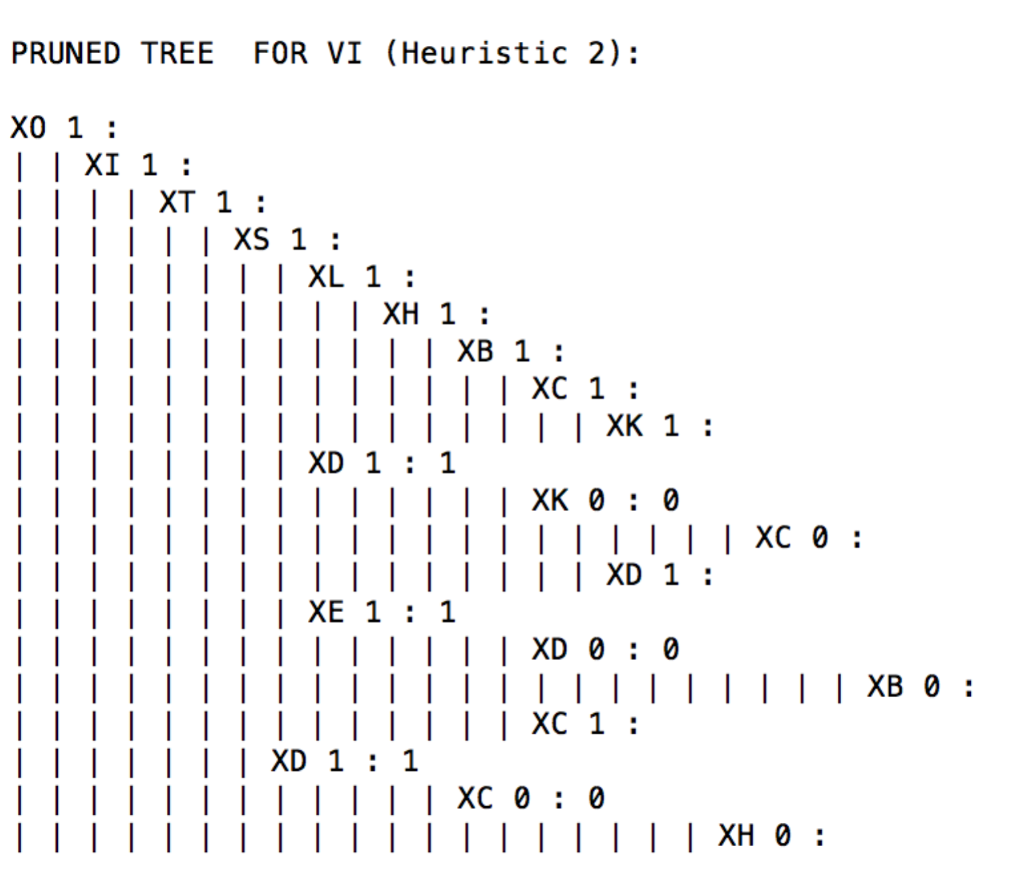

Accuracy: calculated on pruned tree with test data set.

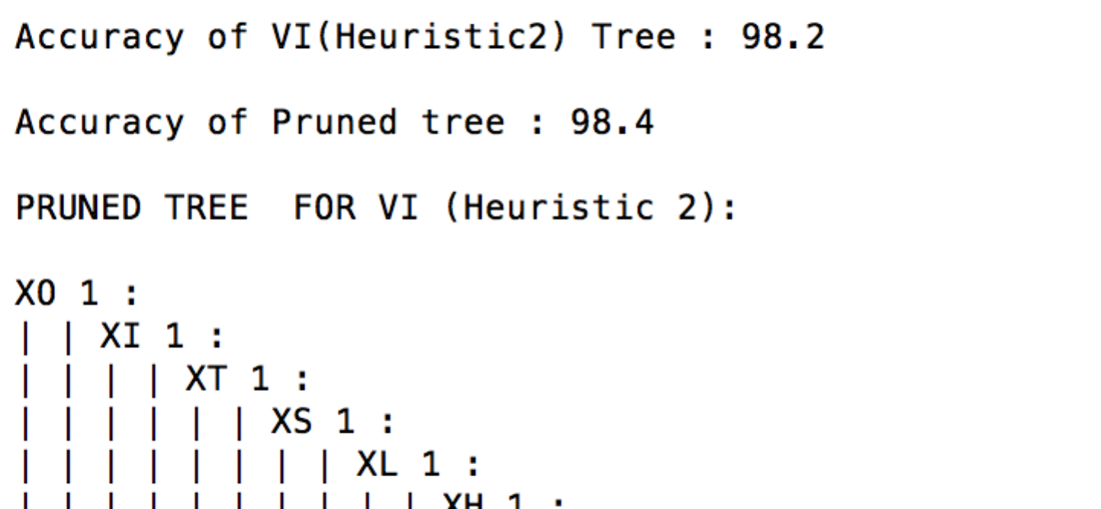

**Example 2:**

1. **Heuristic 1**
   1. **ID3**

Tree: constructed after applying ID3 algorithm on training data set.

Screen shot:

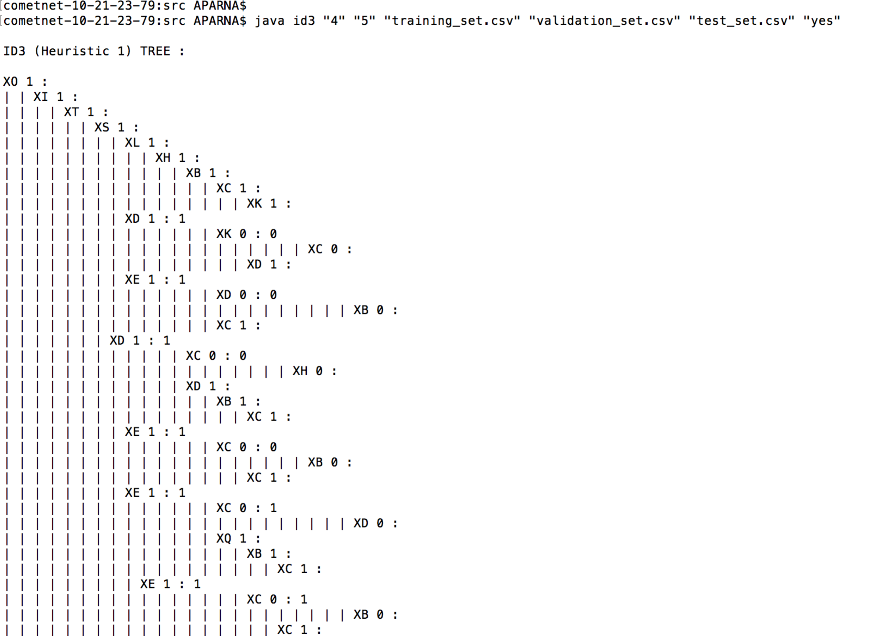

Accuracy: calculated on test data set on the tree, constructed by ID3 algorithm on training data set.

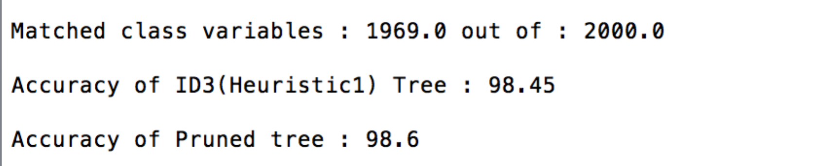

* 1. **Post Pruning**

Tree: Pruned tree on validation data set.

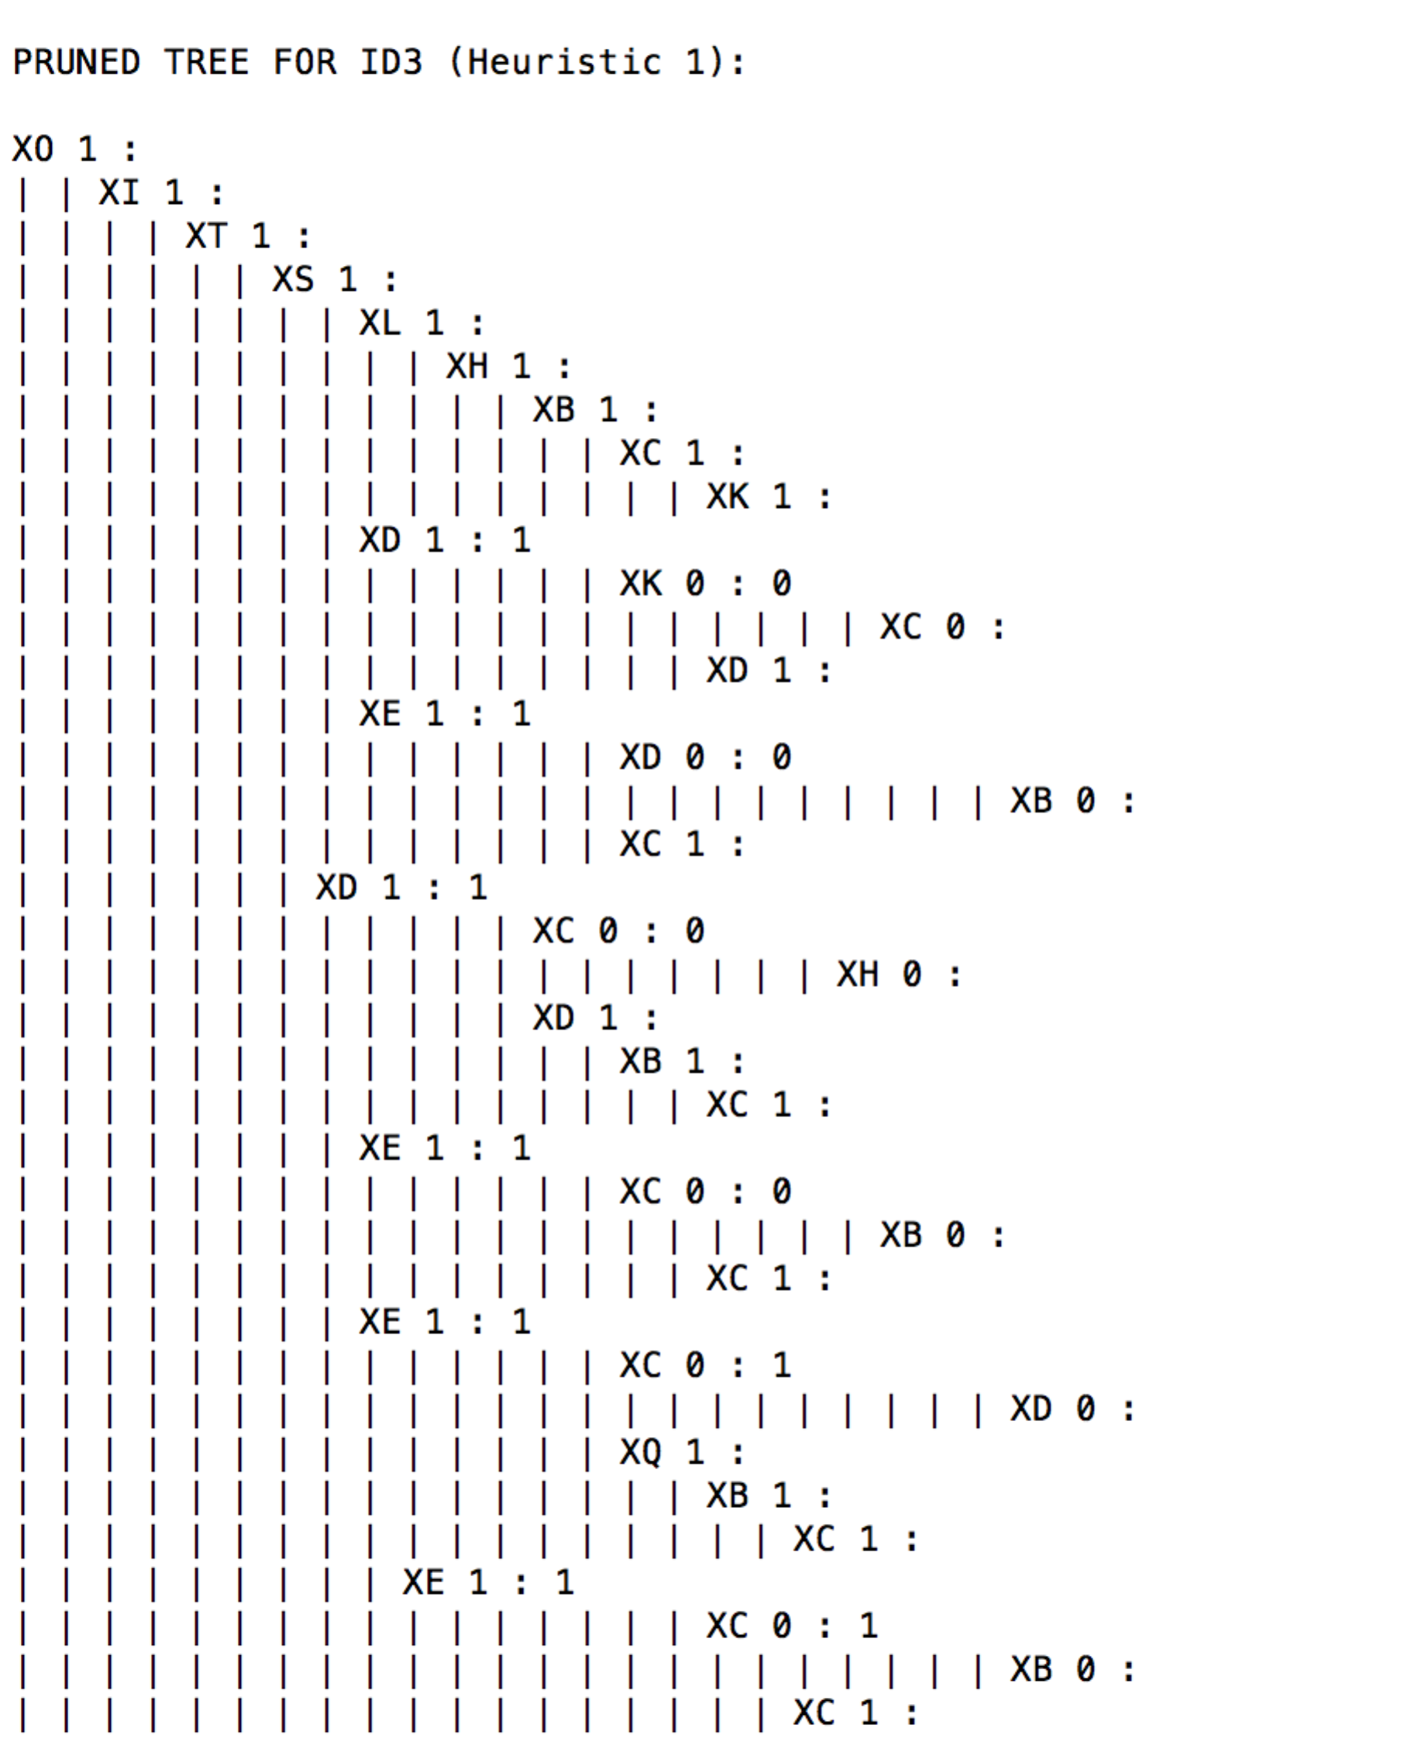

Accuracy: calculated on pruned tree with test data set.

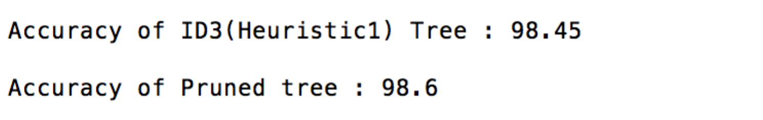

1. **Heuristic 2**
   1. **Algorithm**

Tree: constructed after applying ID3 algorithm on training data set.

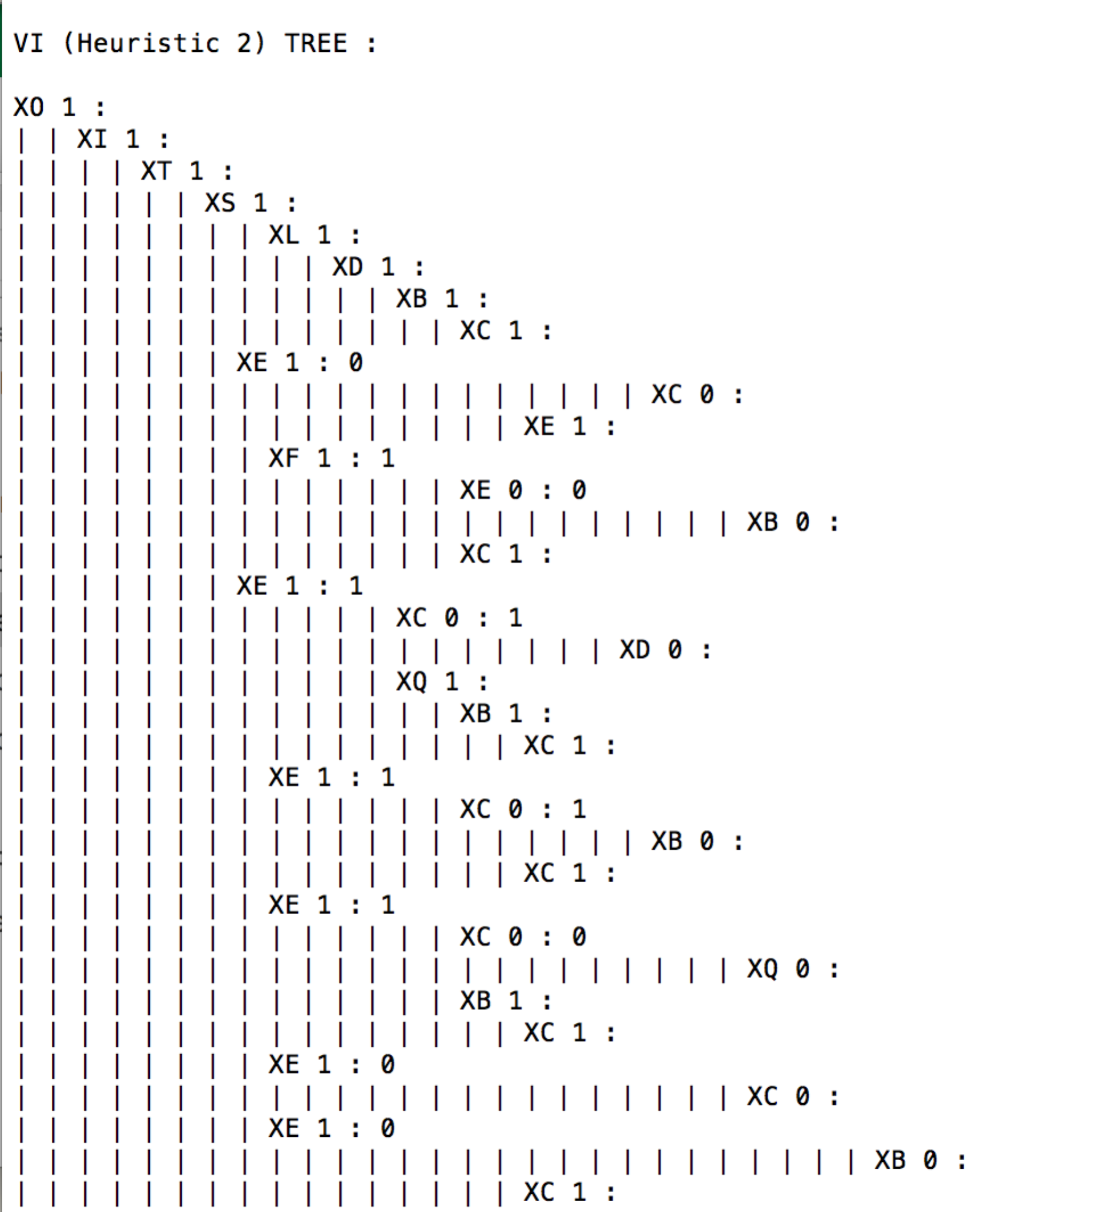

Accuracy: calculated on test data set on the tree, constructed by ID3 algorithm on training data set.

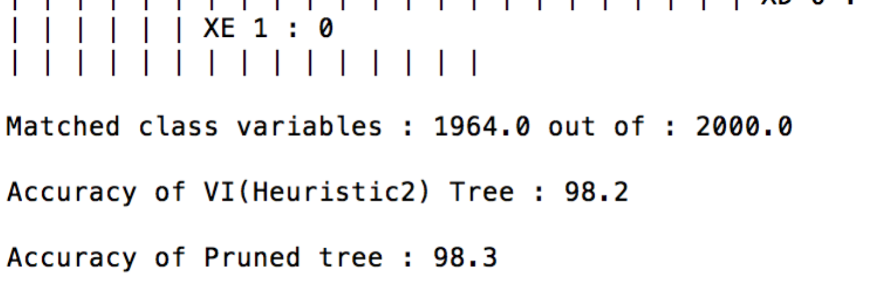

* 1. **Post Pruning**

Tree: Pruned tree on validation data set.

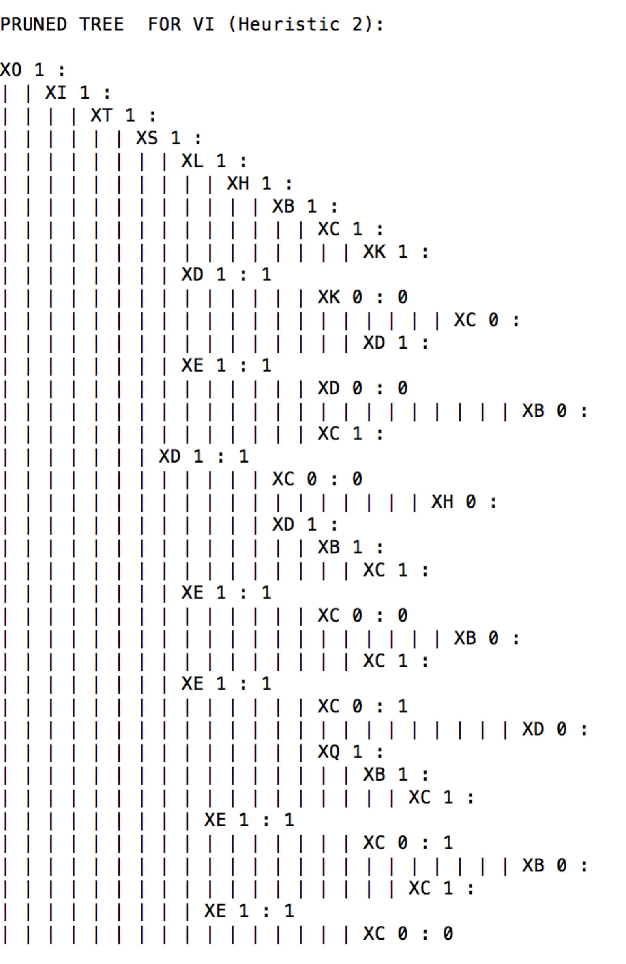

Accuracy: calculated on pruned tree with test data set.

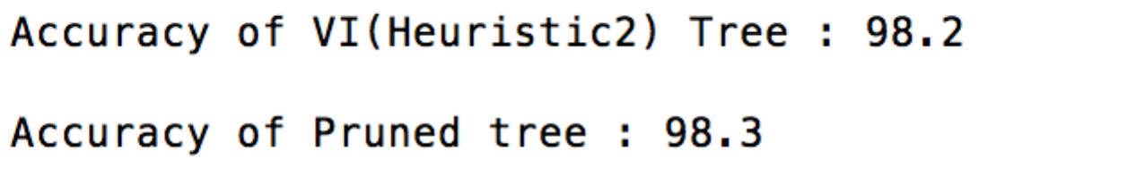

**Example 3:**

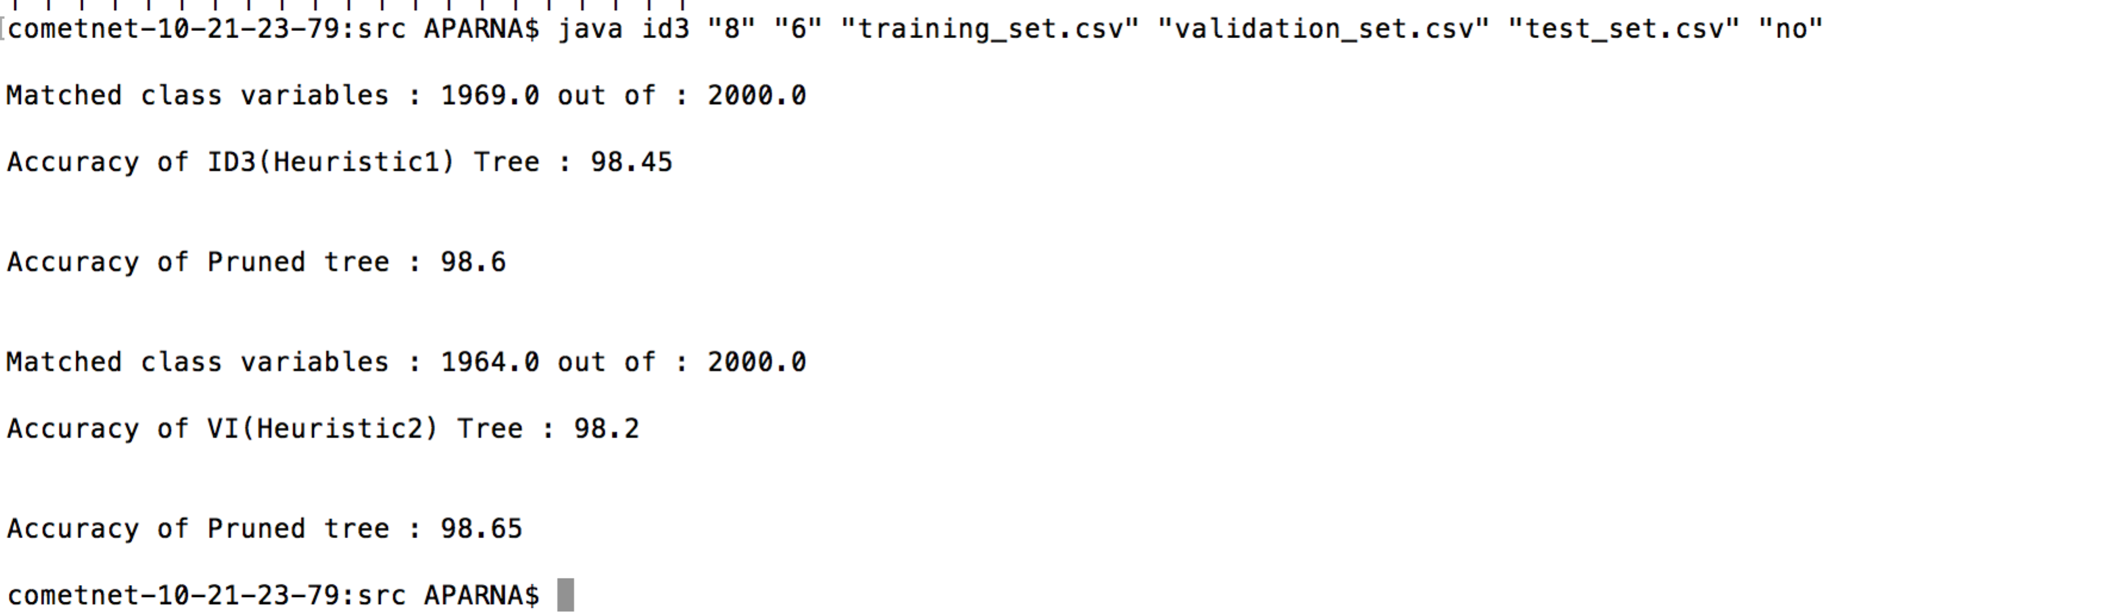

**Example 4:**

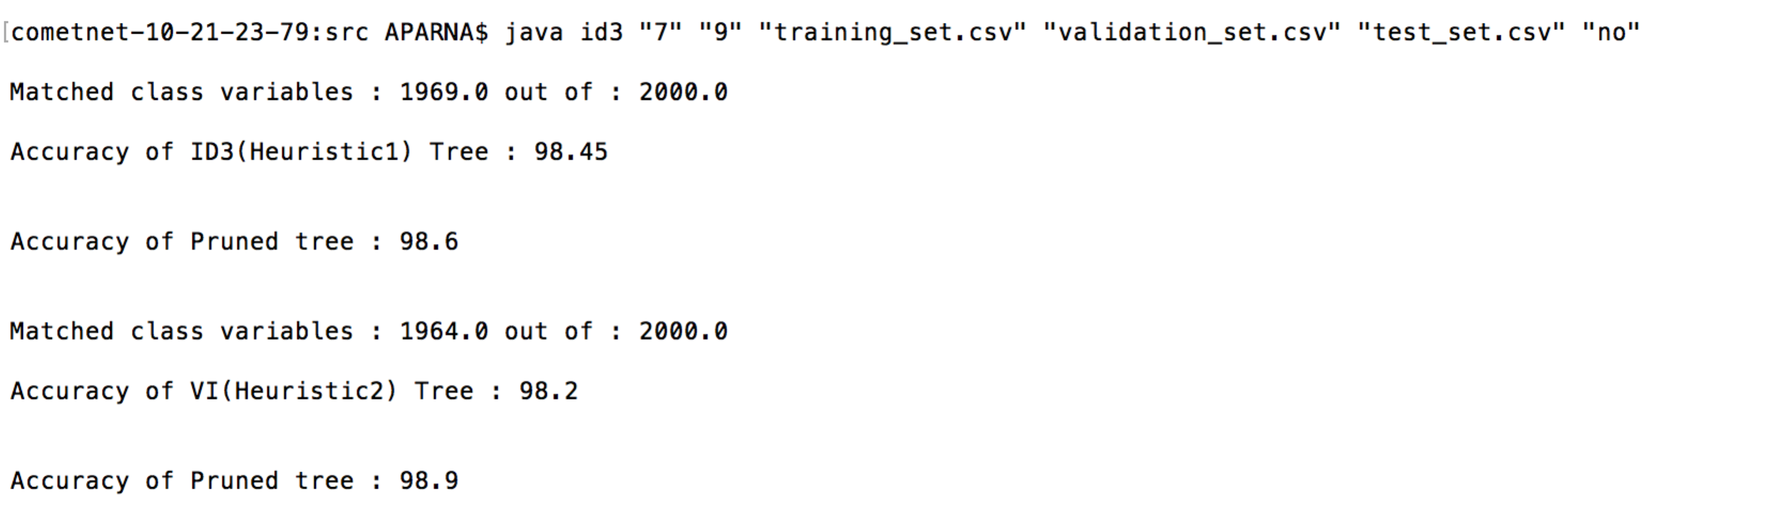

**Example 5:**

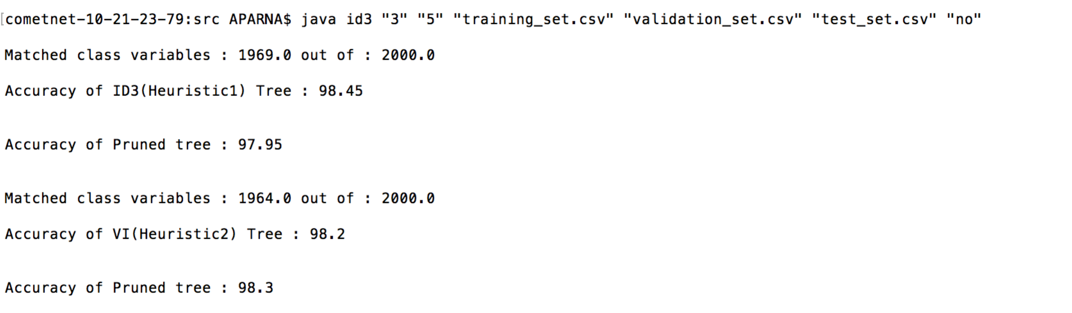

In this example accuracy did not improve for the first heuristic. So it is not required to change the tree with new tree. For the second heuristic, accuracy is improved by 0.1 percentages.

**Example 6:**

1. **Heuristic 1**
   1. **ID3**

Tree: constructed after applying ID3 algorithm on training data set.

Screen shot:

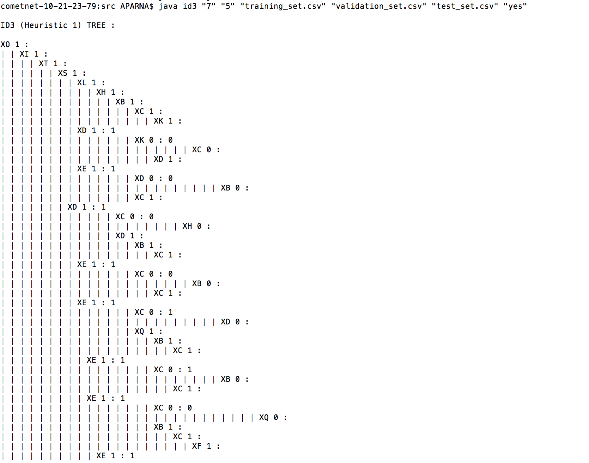

Accuracy: calculated on test data set on the tree, constructed by ID3 algorithm on training data set.

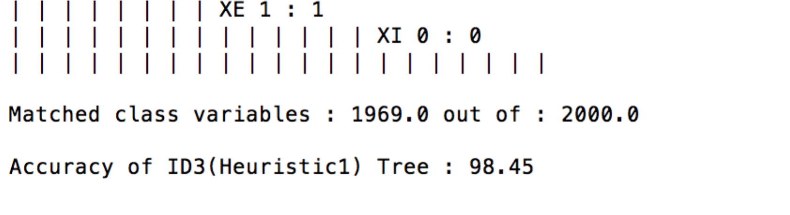

* 1. **Post Pruning**

Tree: Pruned tree on validation data set.

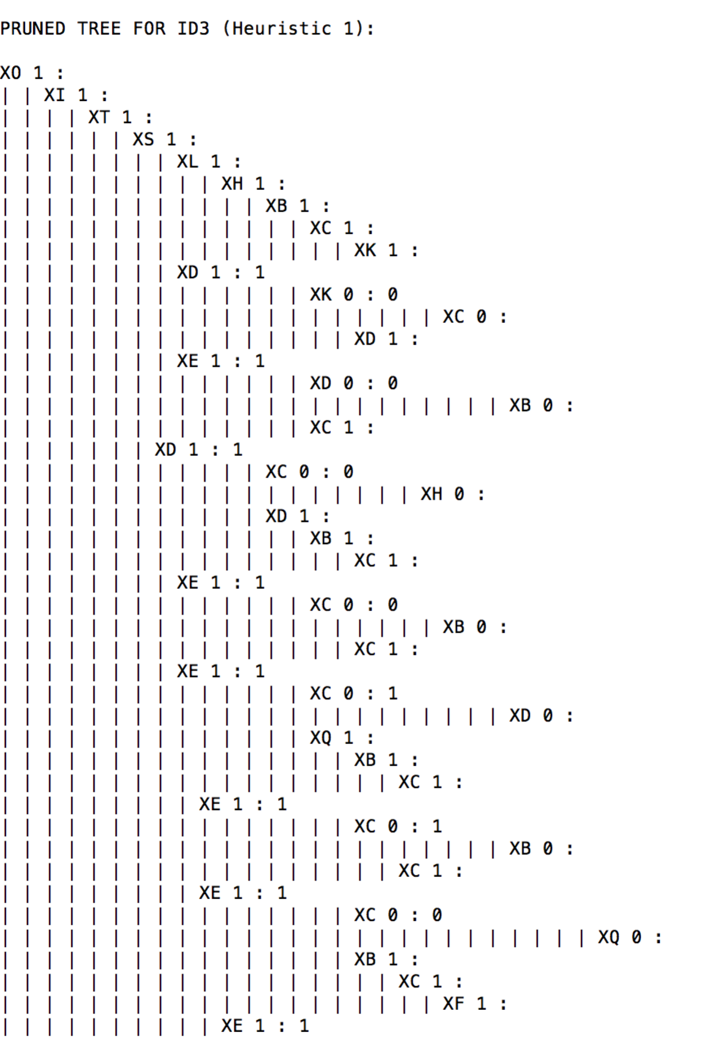

Accuracy: calculated on pruned tree with test data set.

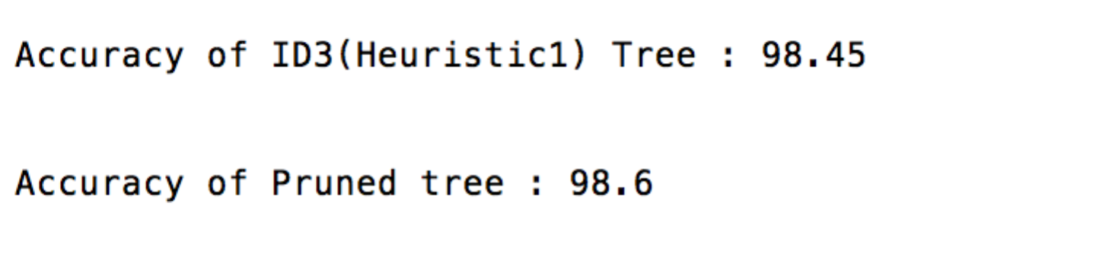

1. **Heuristic 2**
   1. **Algorithm**

Tree: constructed after applying ID3 algorithm on training data set.

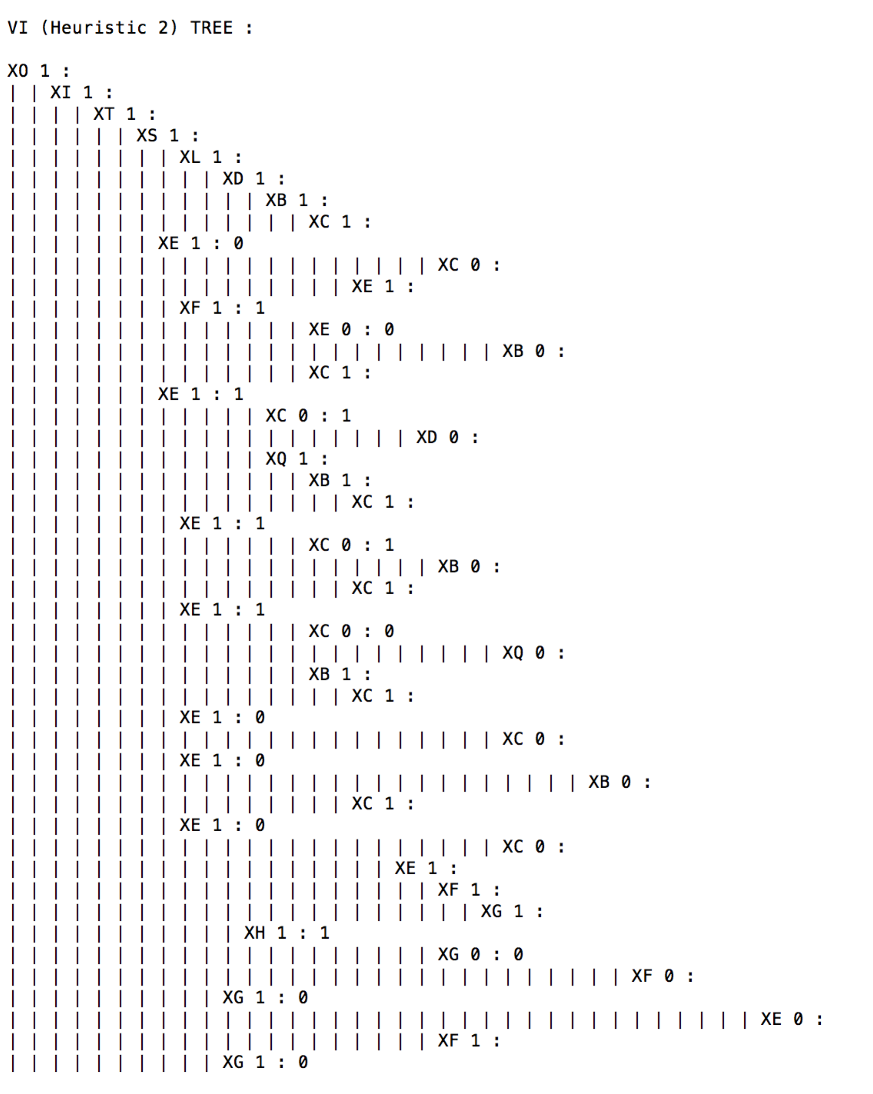

Accuracy: calculated on test data set on the tree, constructed by ID3 algorithm on training data set.

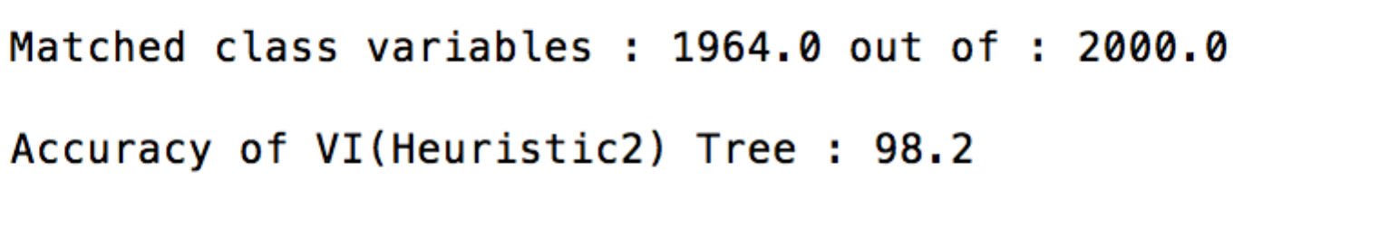

* 1. **Post Pruning**

Tree: Pruned tree on validation data set.

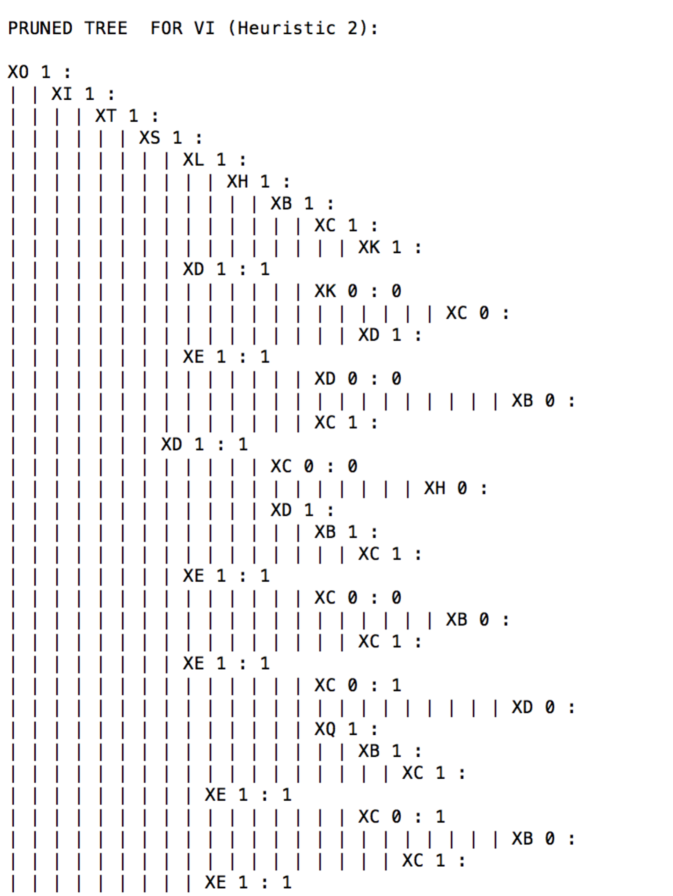

Accuracy: calculated on pruned tree with test data set.

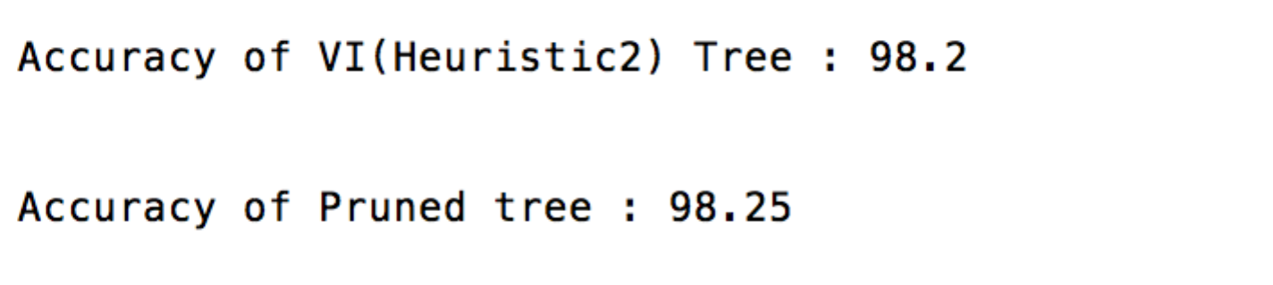

**Example 7:**

1. **Heuristic 1**
   1. **ID3**

Tree: constructed after applying ID3 algorithm on training data set.

Screen shot:

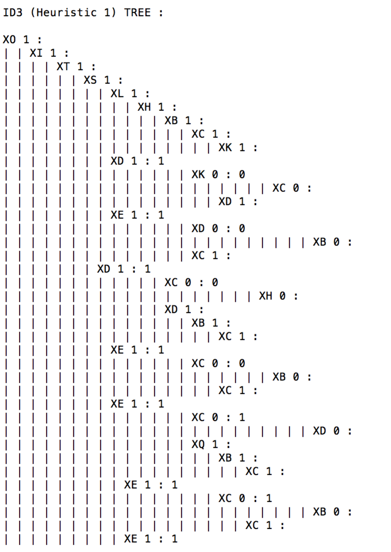

Accuracy: calculated on test data set on the tree, constructed by ID3 algorithm on training data set.

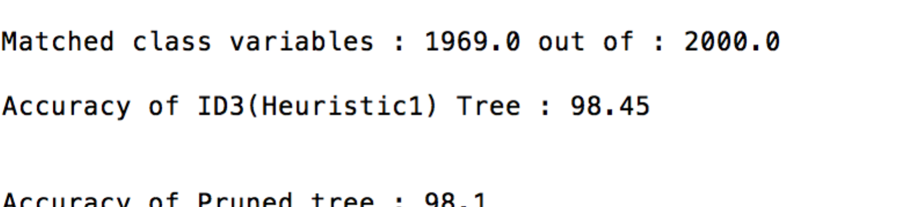

* 1. **Post Pruning**

Tree: Pruned tree on validation data set.

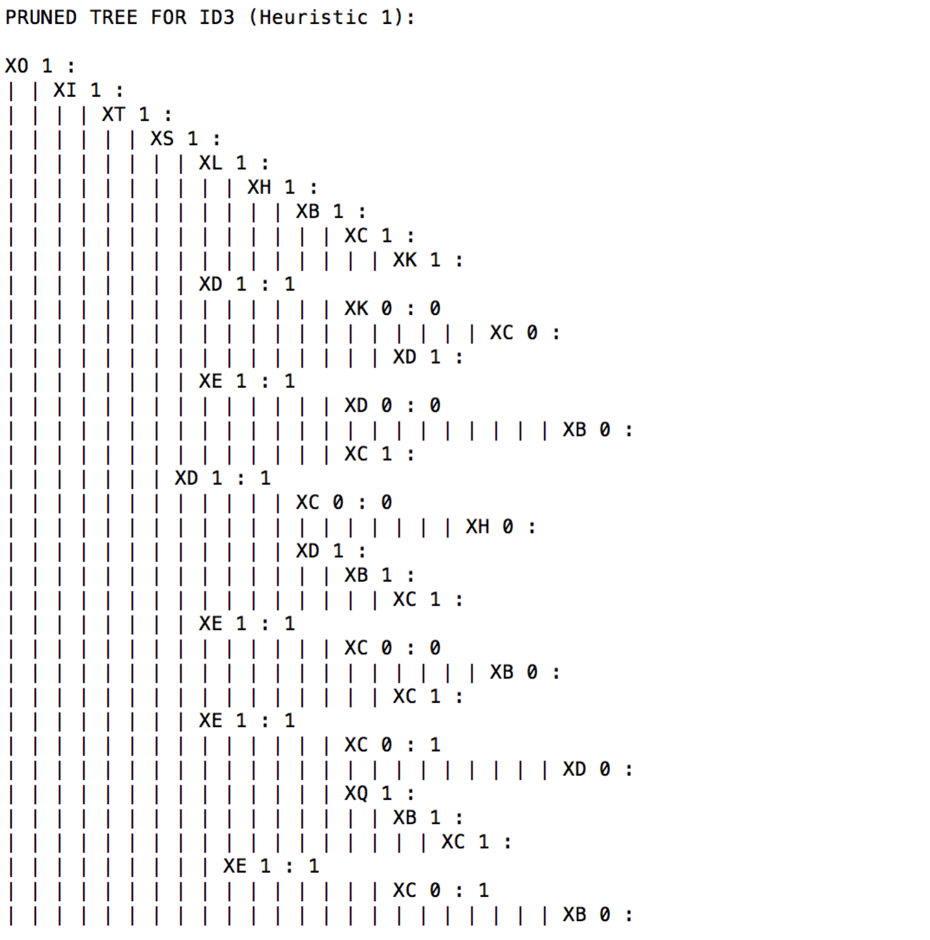

Accuracy: calculated on pruned tree with test data set.

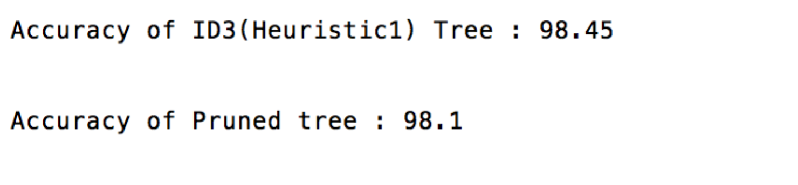

1. **Heuristic 2**
   1. **Algorithm**

Tree: constructed after applying ID3 algorithm on training data set.

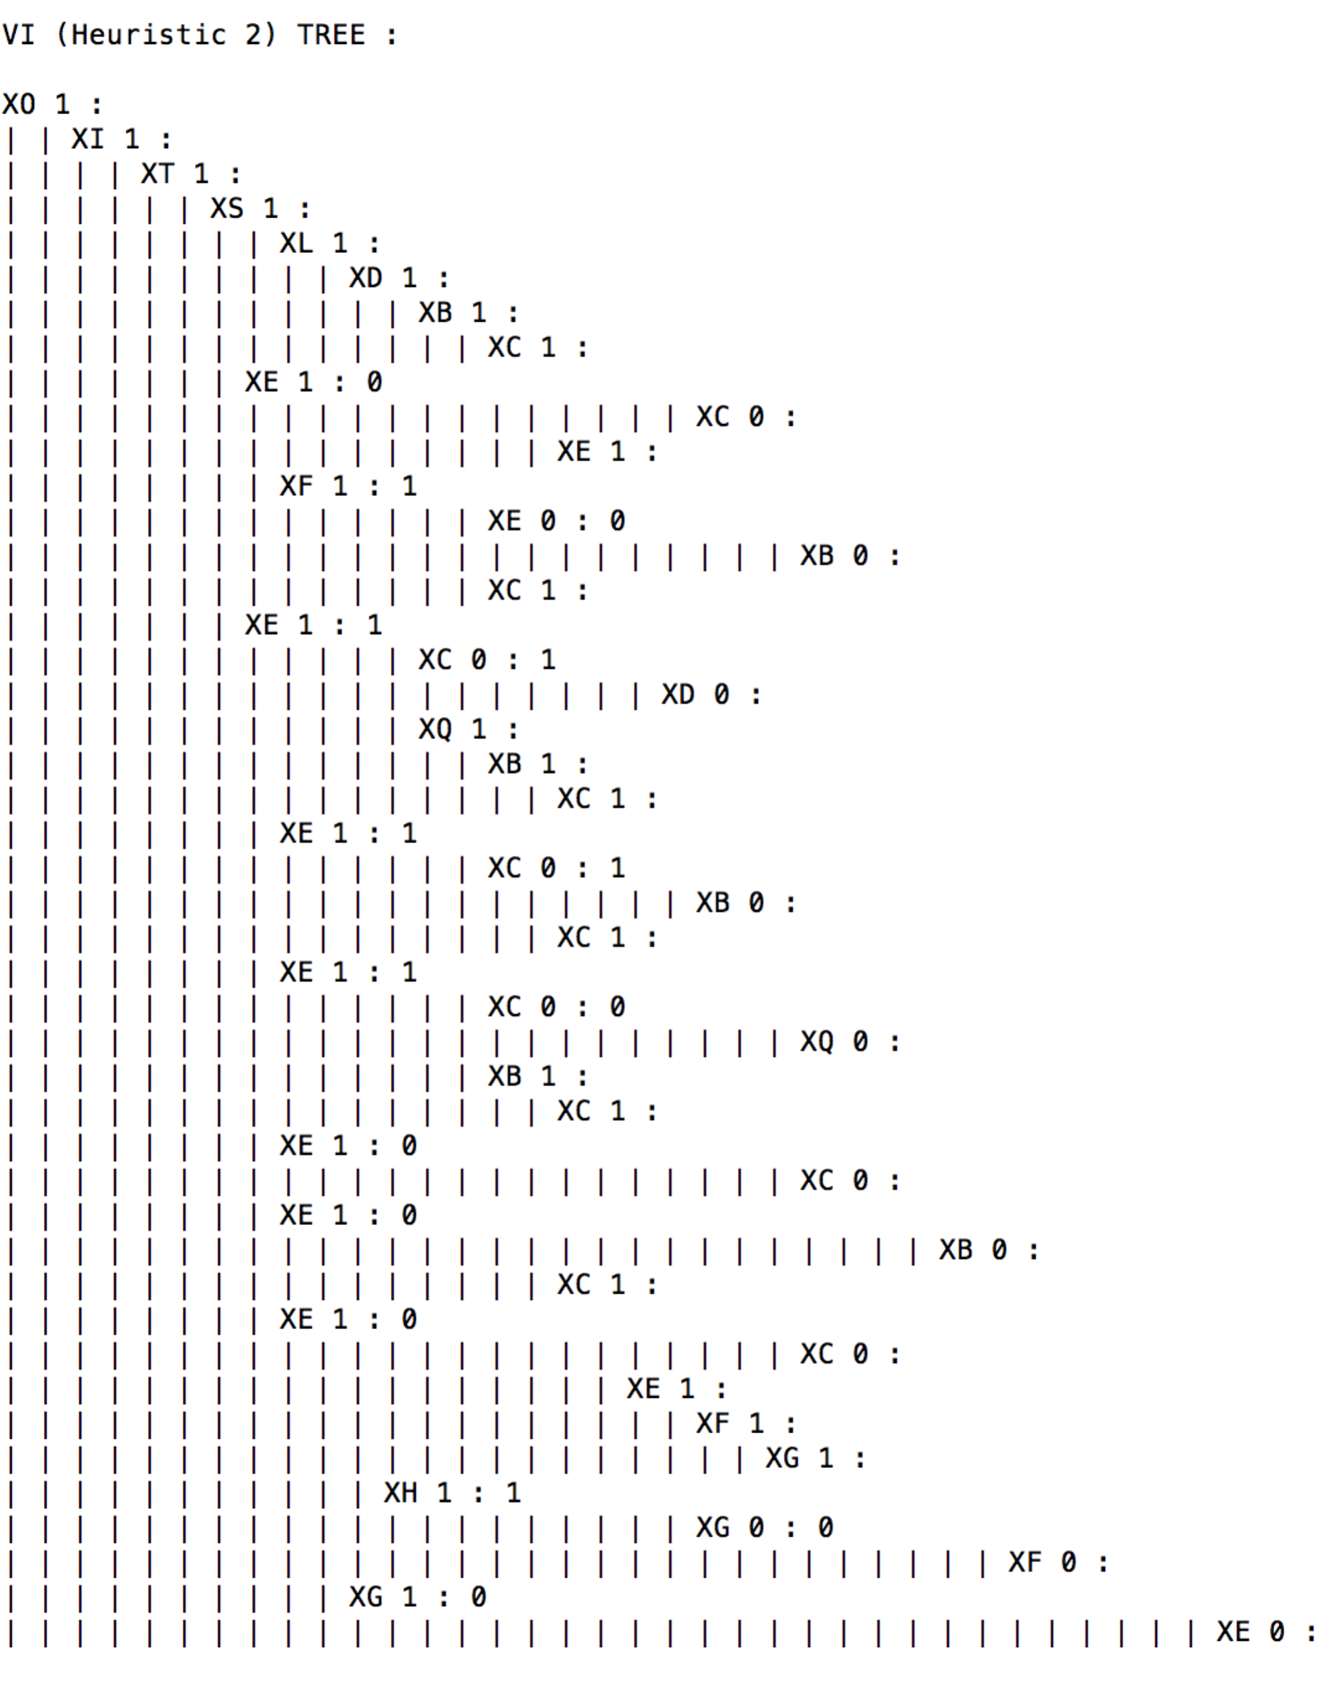

Accuracy: calculated on test data set on the tree, constructed by ID3 algorithm on training data set.

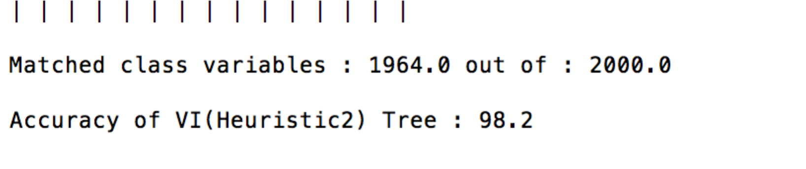

* 1. **Post Pruning**

Tree: Pruned tree on validation data set.

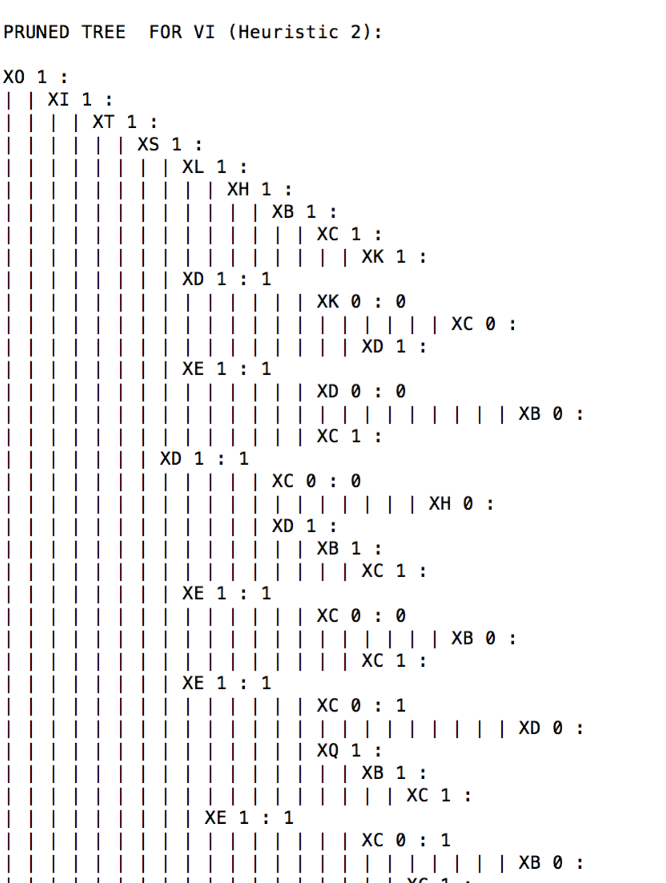

Accuracy: calculated on pruned tree with test data set.

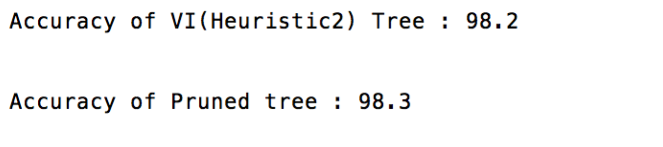

**Example 8:**

1. **Heuristic 1**
   1. **ID3**

Tree: constructed after applying ID3 algorithm on training data set.

Screen shot:

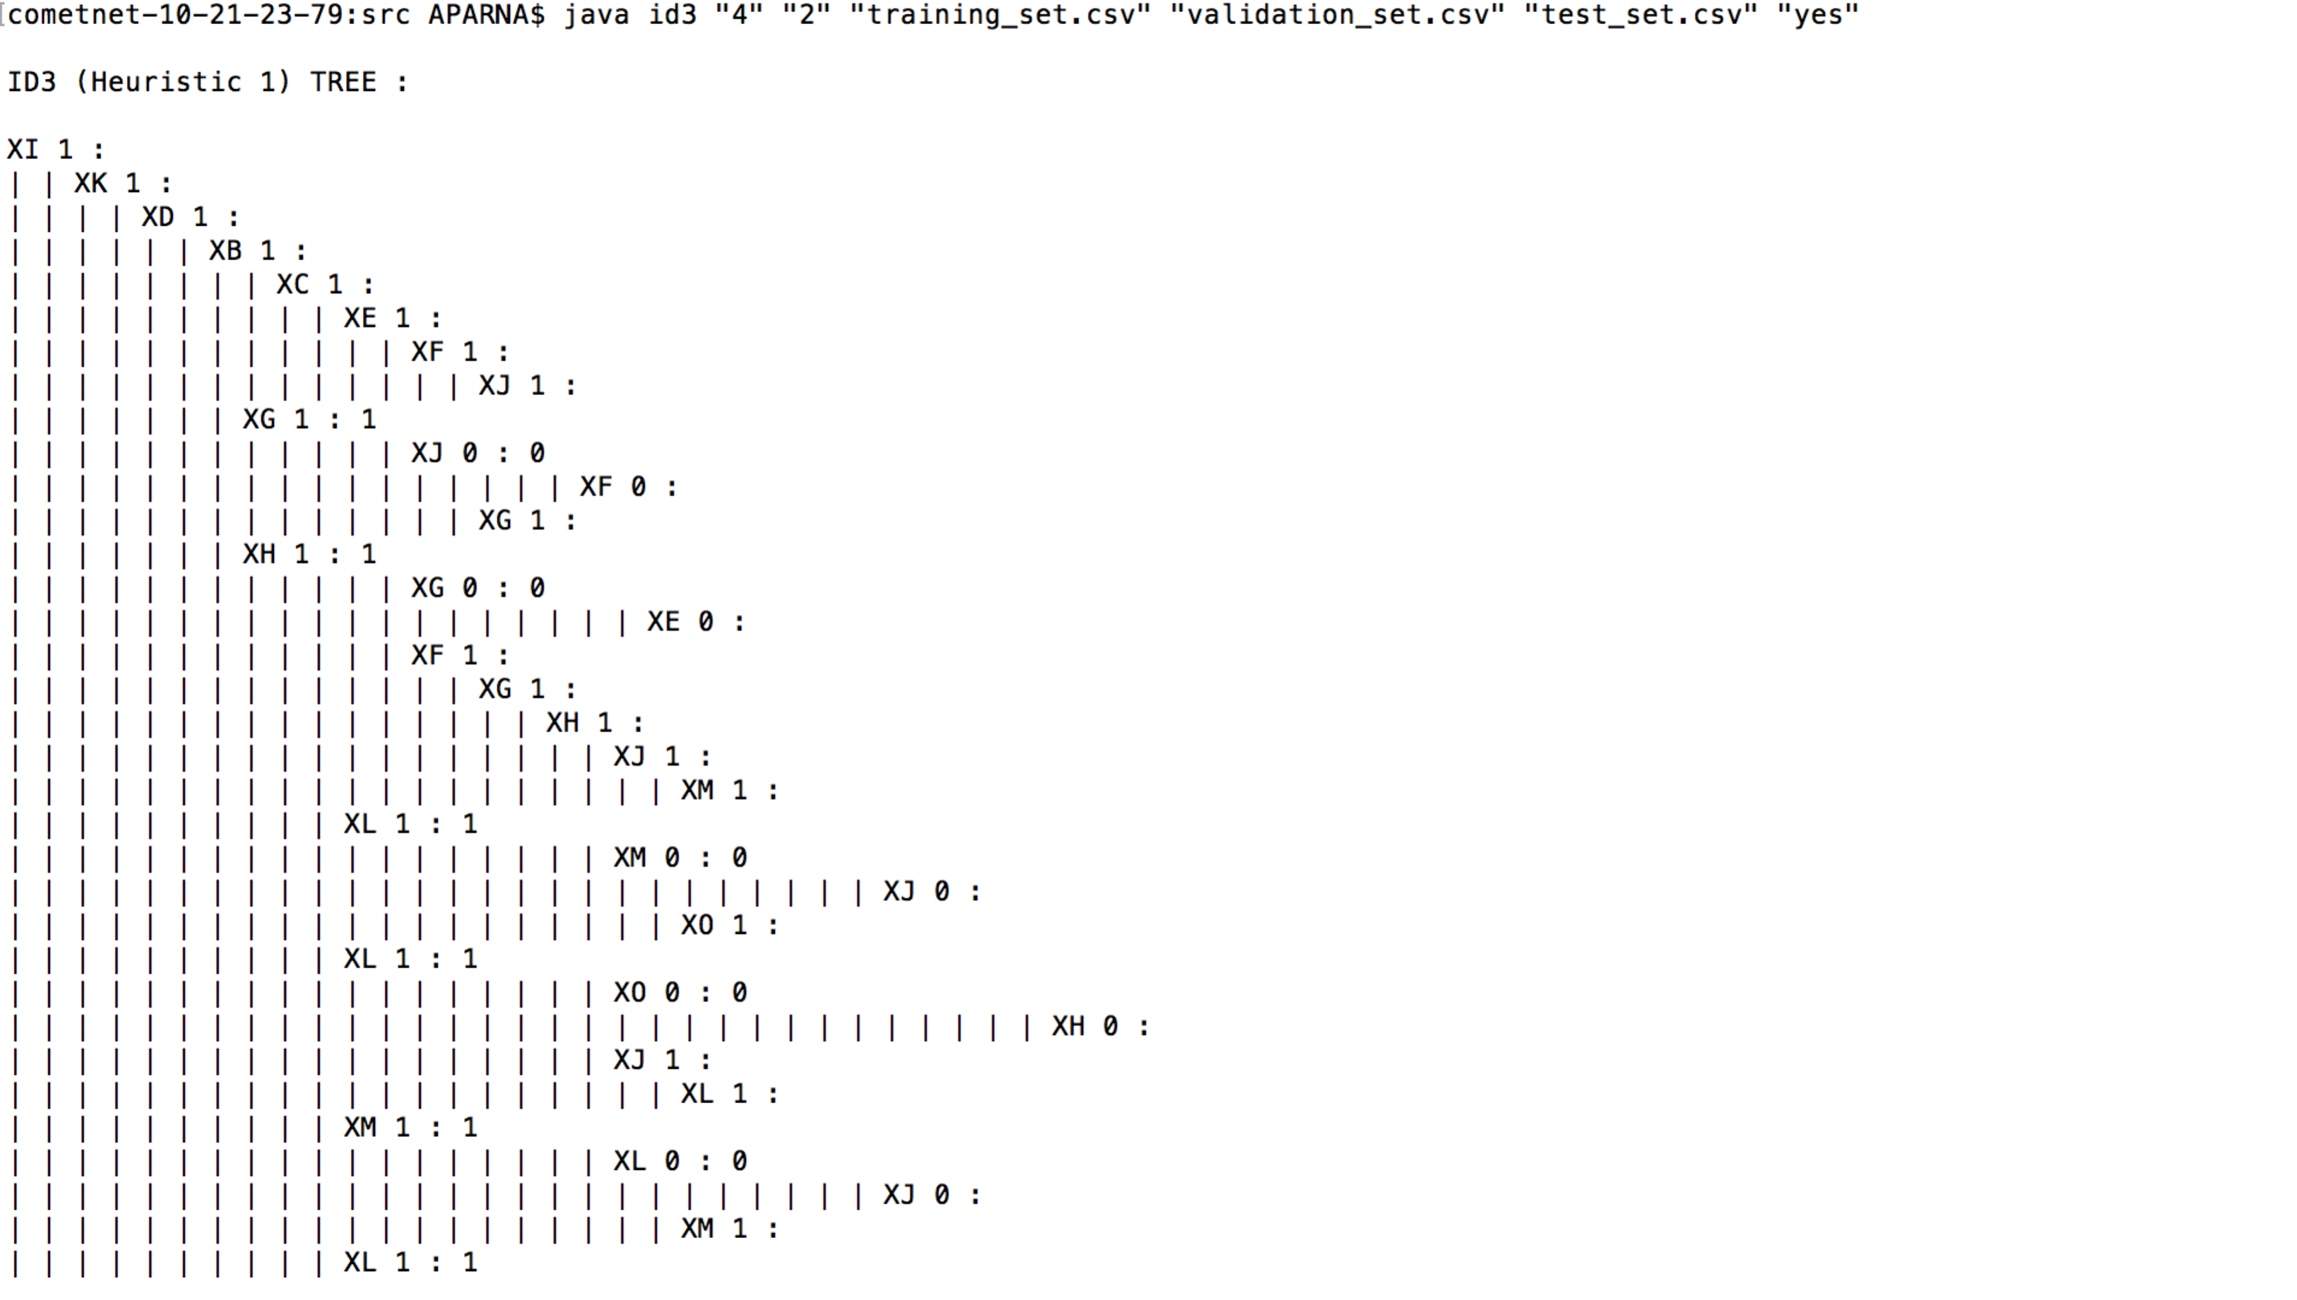

Accuracy: calculated on test data set on the tree, constructed by ID3 algorithm on training data set.

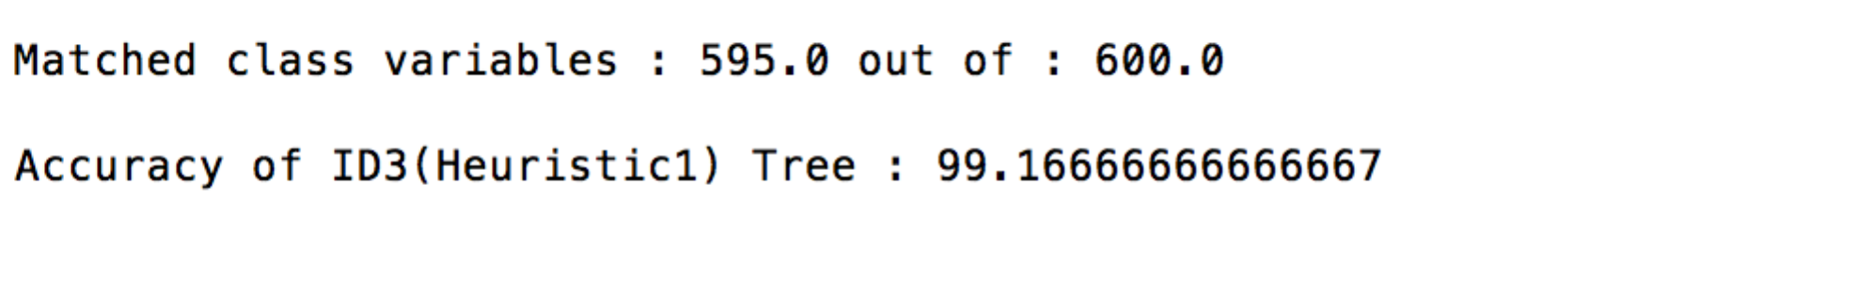

* 1. **Post Pruning**

Tree: Pruned tree on validation data set.

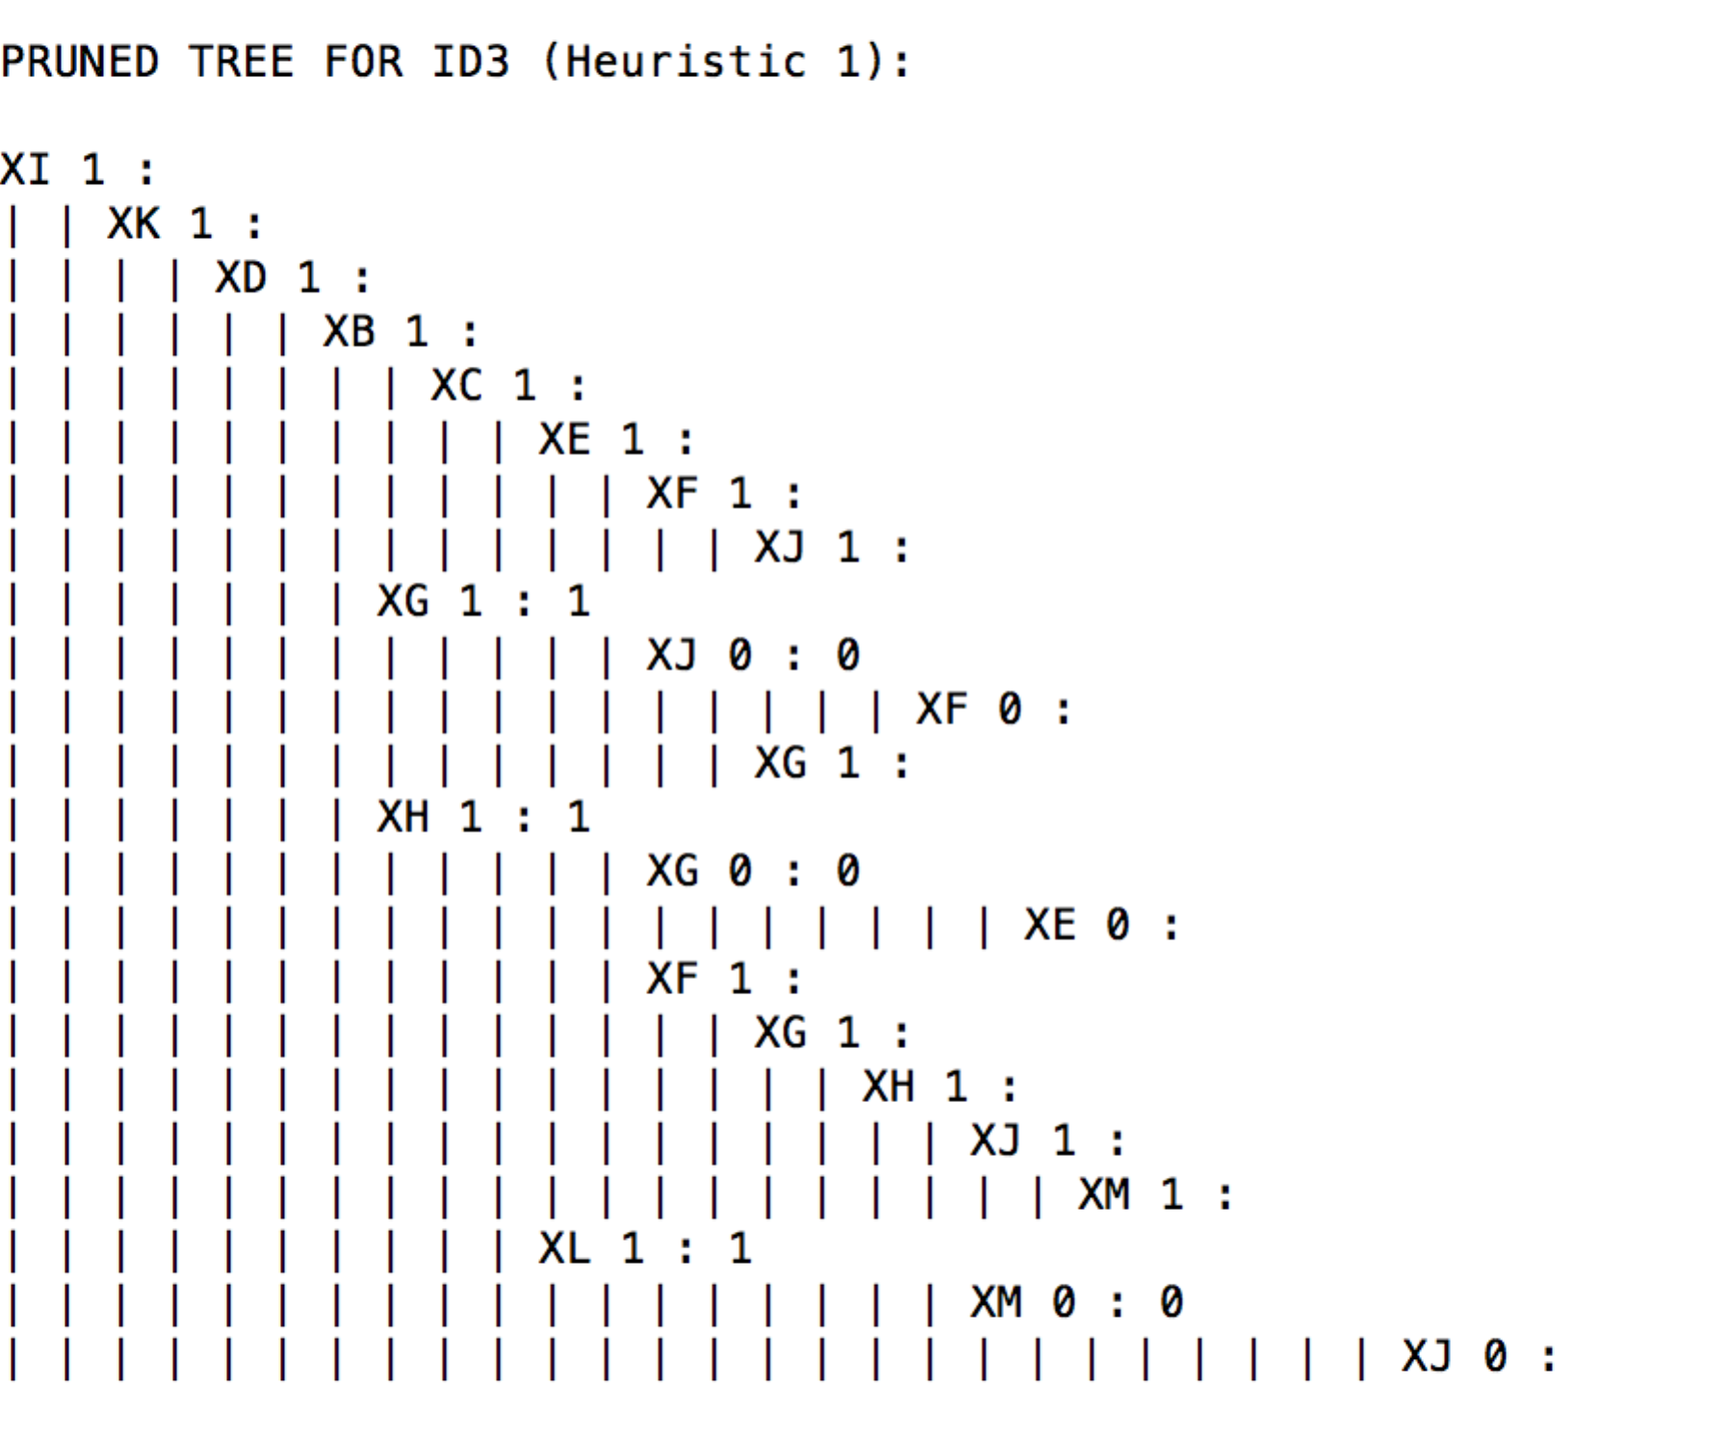

Accuracy: calculated on pruned tree with test data set.

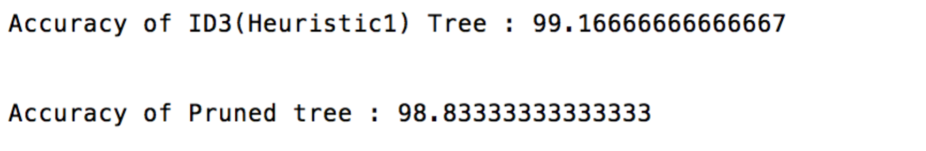

1. **Heuristic 2**
   1. **Algorithm**

Tree: constructed after applying ID3 algorithm on training data set.

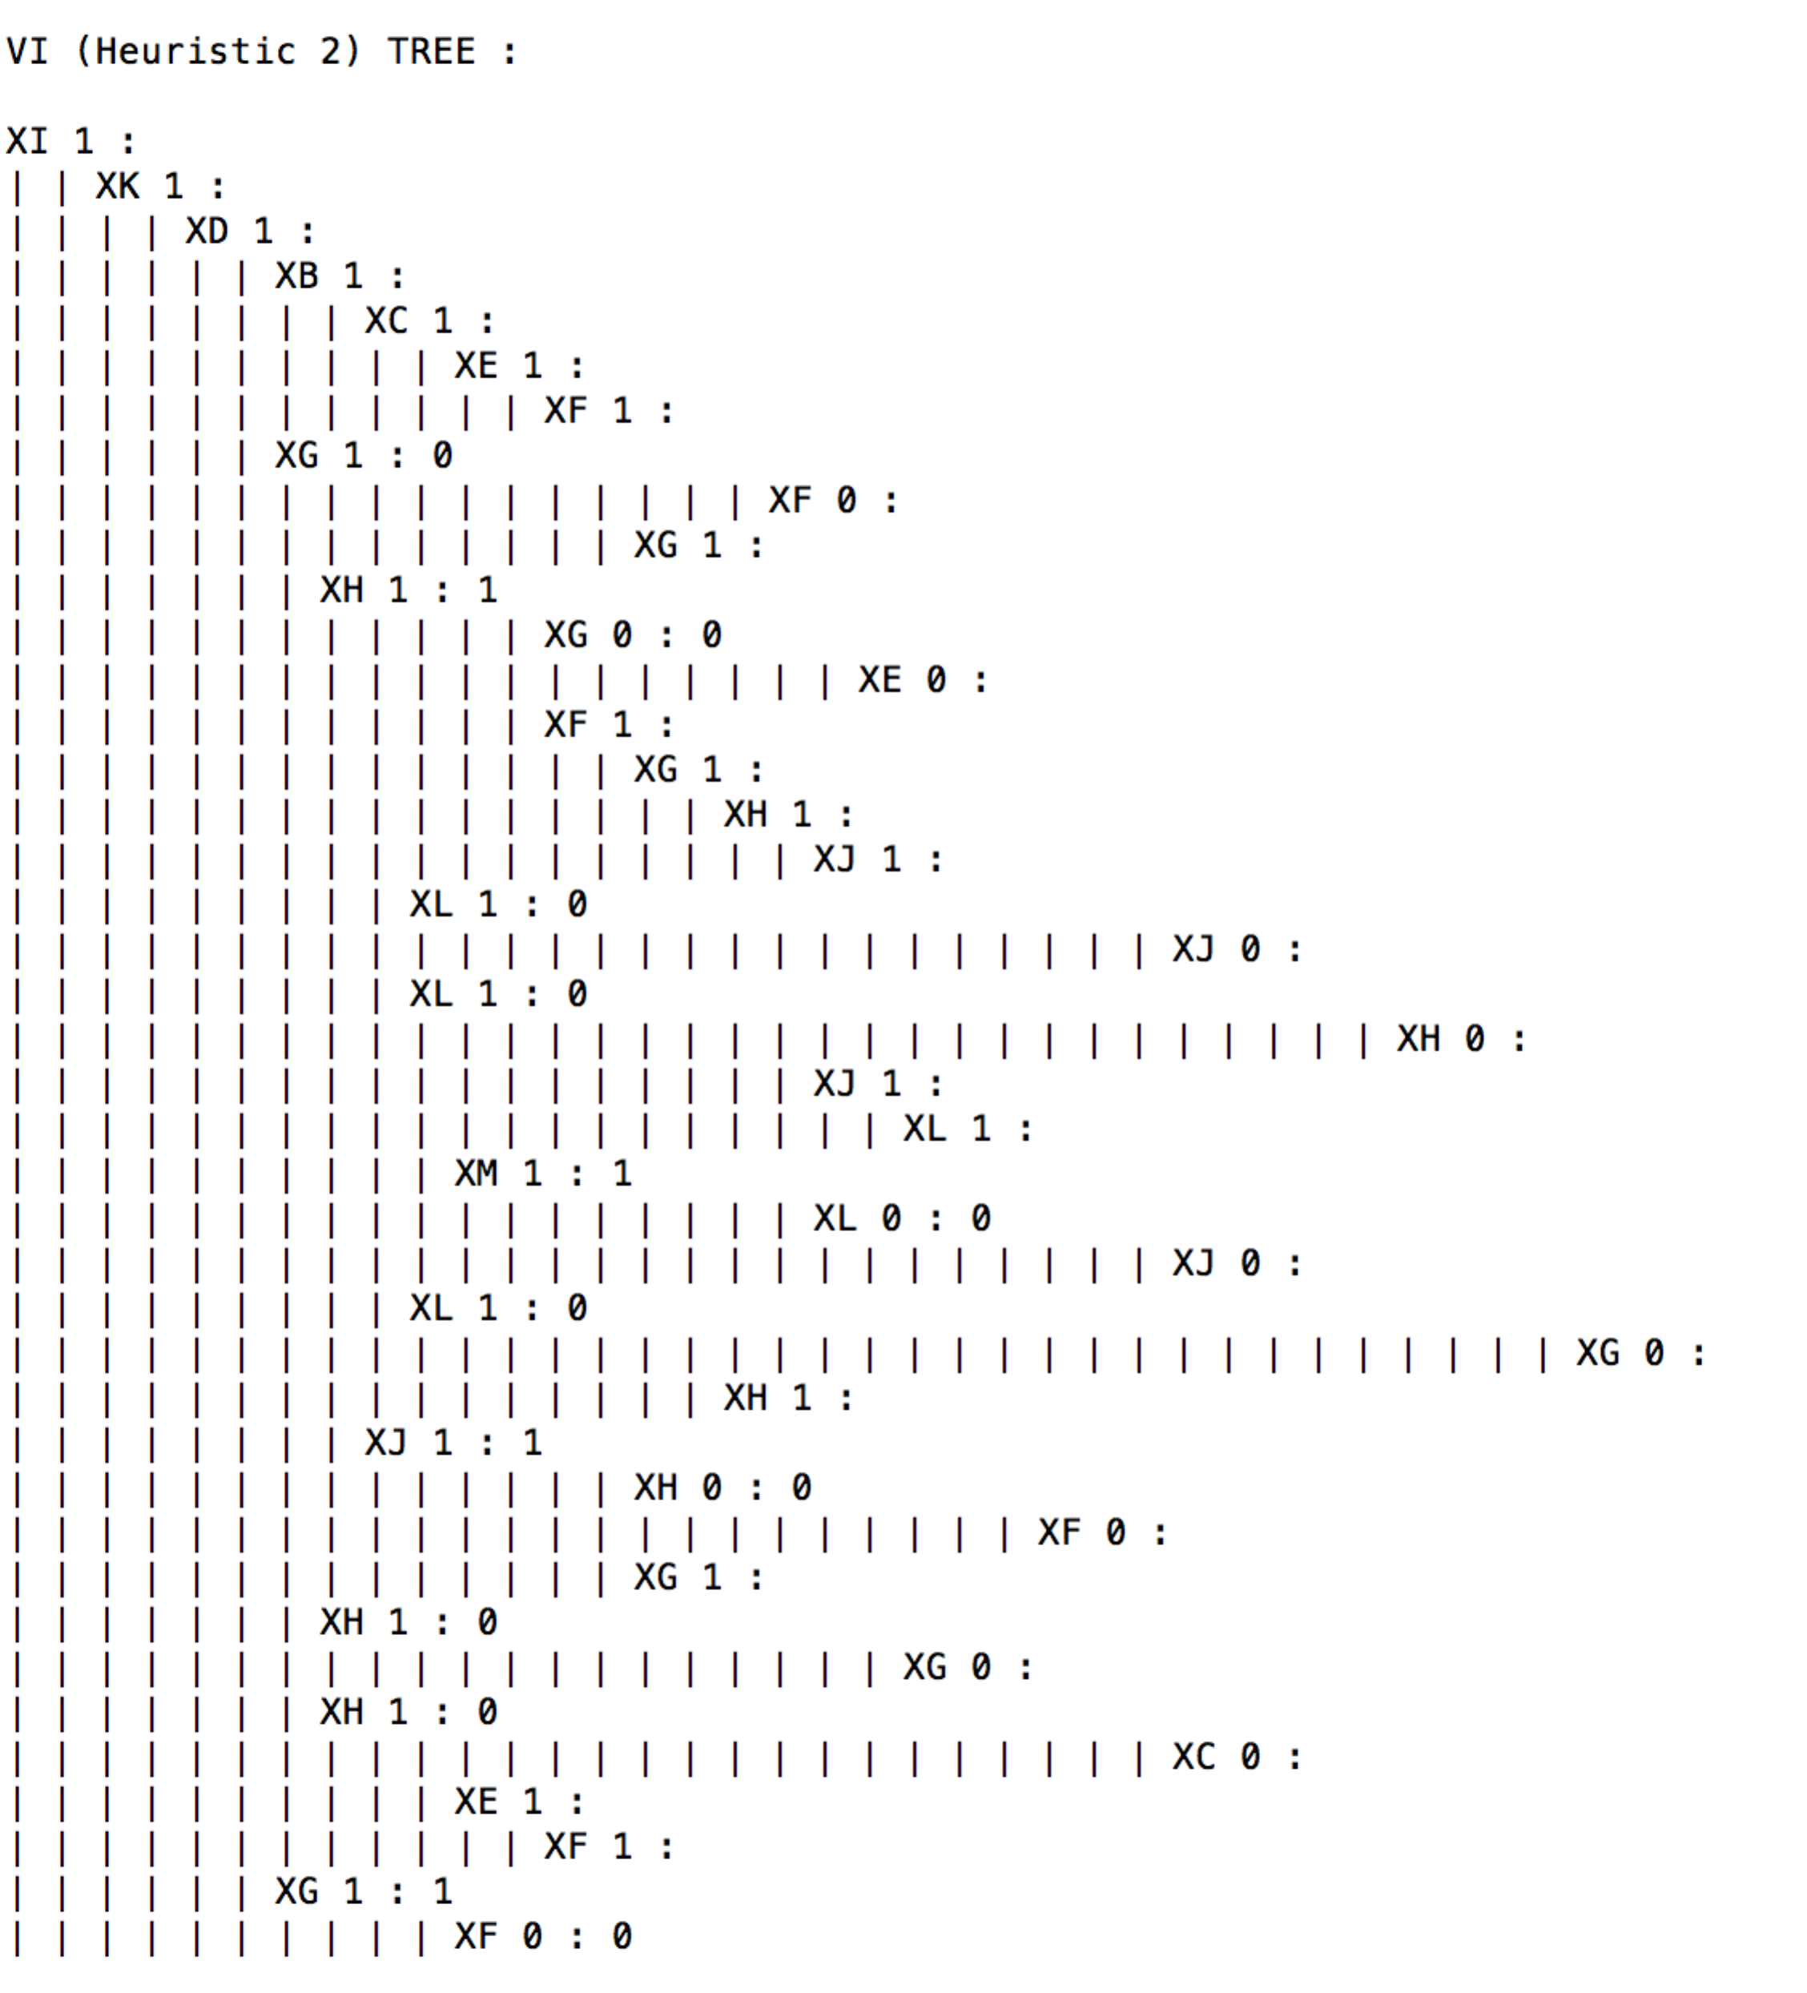

Accuracy: calculated on test data set on the tree, constructed by ID3 algorithm on training data set.

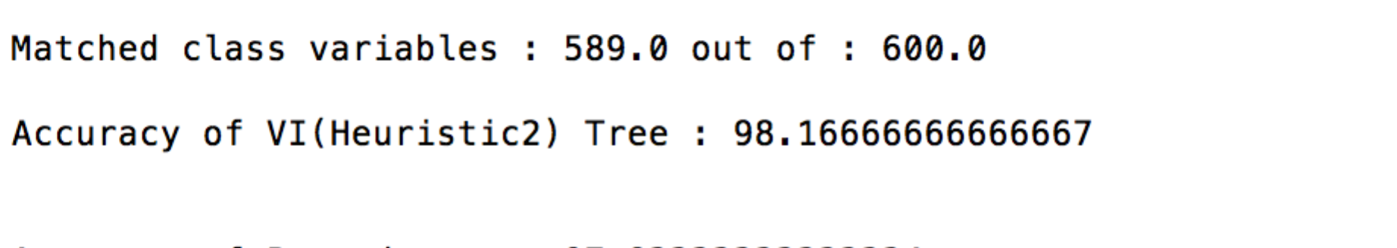

* 1. **Post Pruning**

Tree: Pruned tree on validation data set.

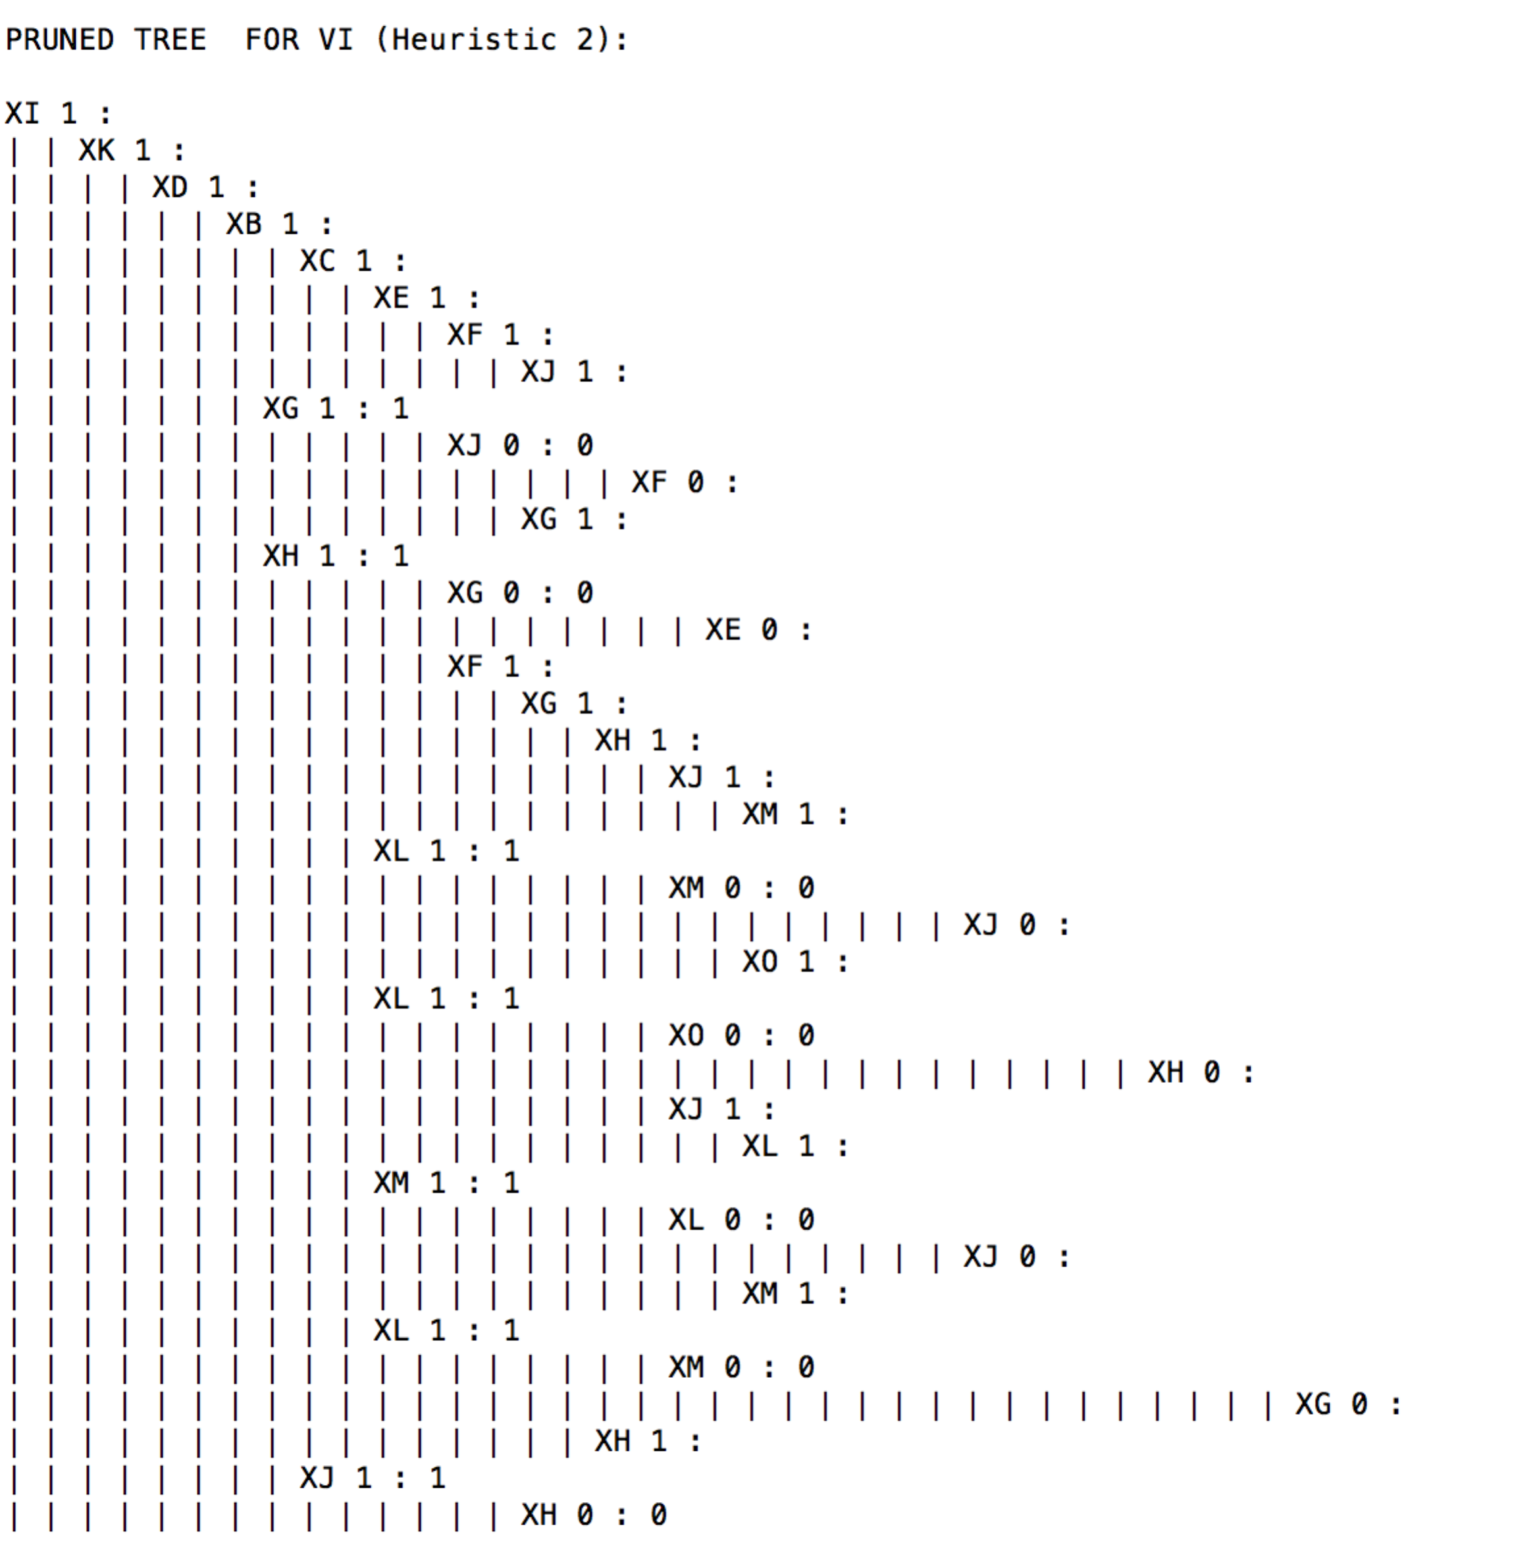

Accuracy: calculated on pruned tree with test data set.

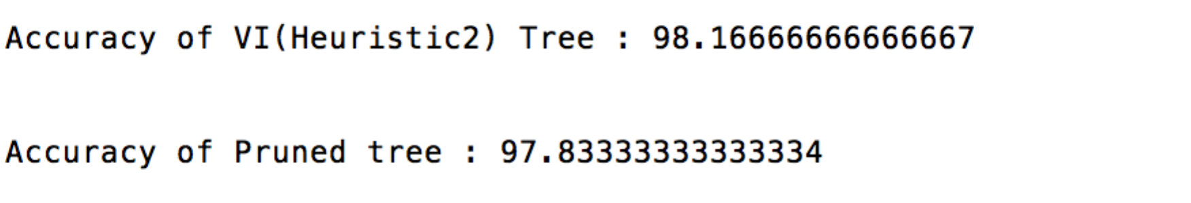

**Example 9:**

1. **Heuristic 1**
   1. **ID3**

Tree: constructed after applying ID3 algorithm on training data set.

Screen shot:

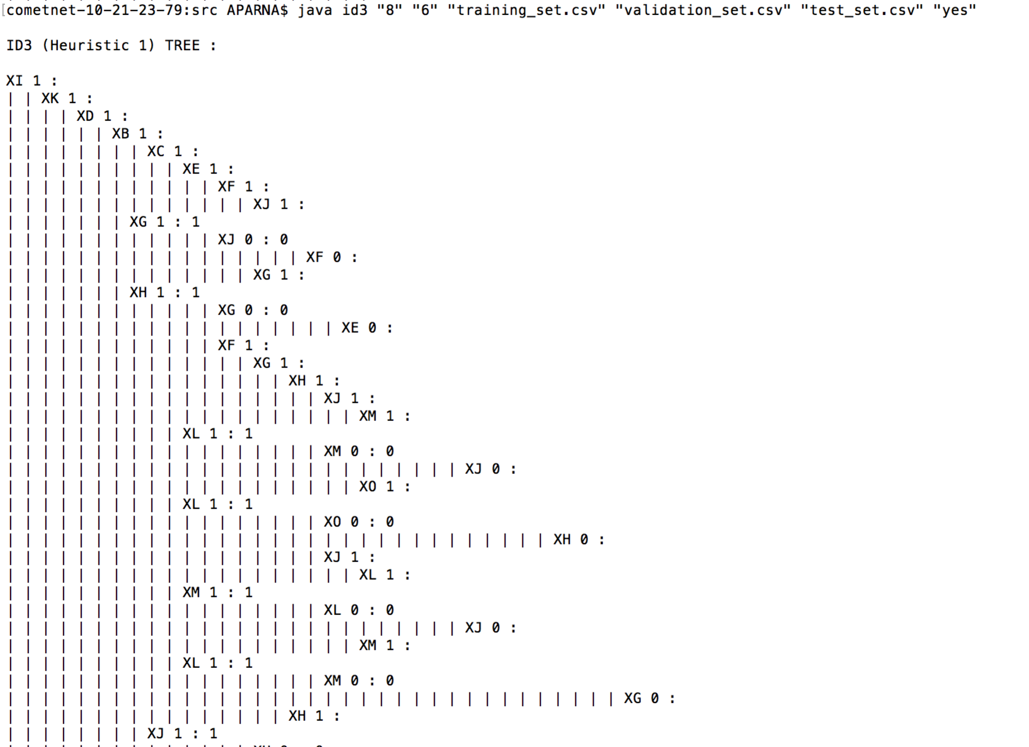

Accuracy: calculated on test data set on the tree, constructed by ID3 algorithm on training data set.

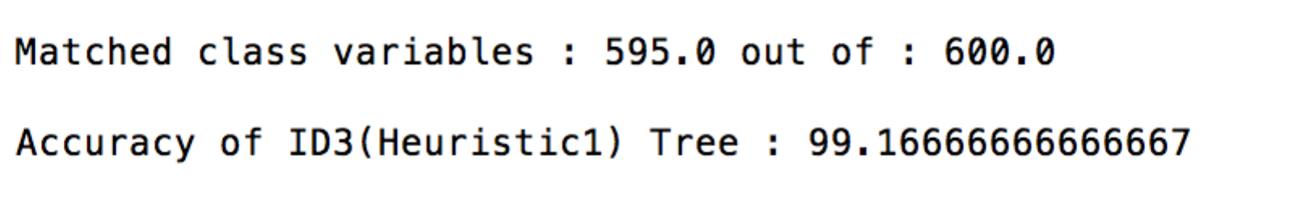

* 1. **Post Pruning**

Tree: Pruned tree on validation data set.

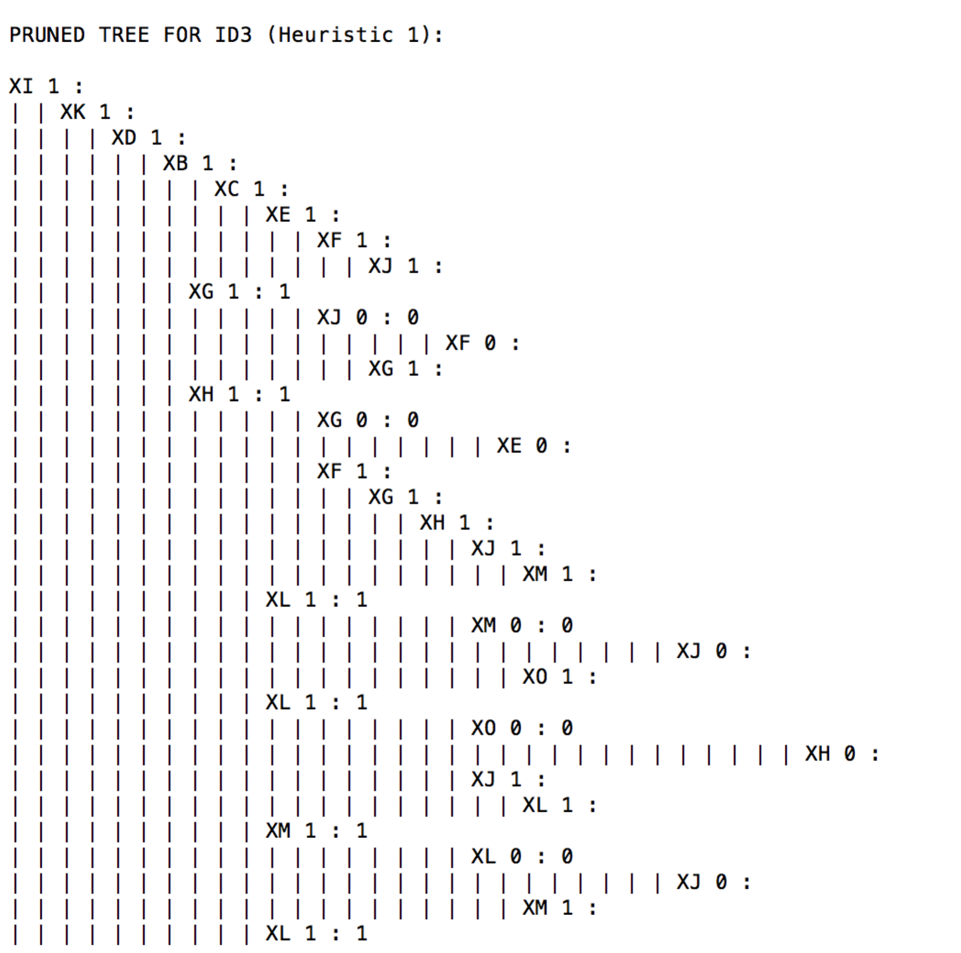

Accuracy: calculated on pruned tree with test data set.

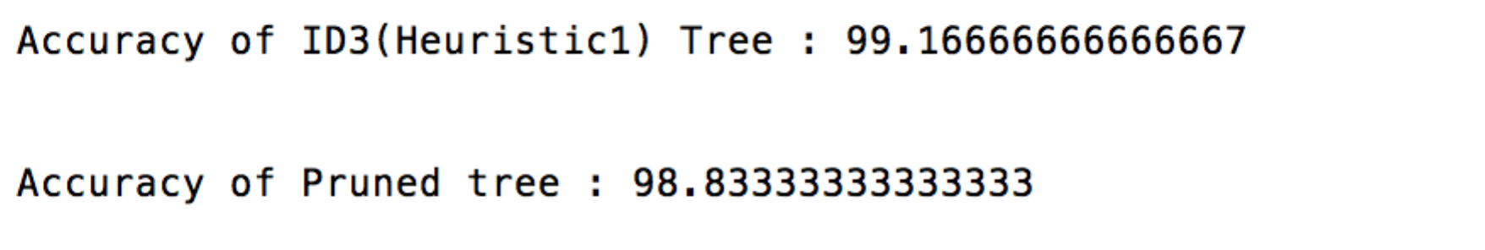

1. **Heuristic 2**
   1. **Algorithm**

Tree: constructed after applying ID3 algorithm on training data set.

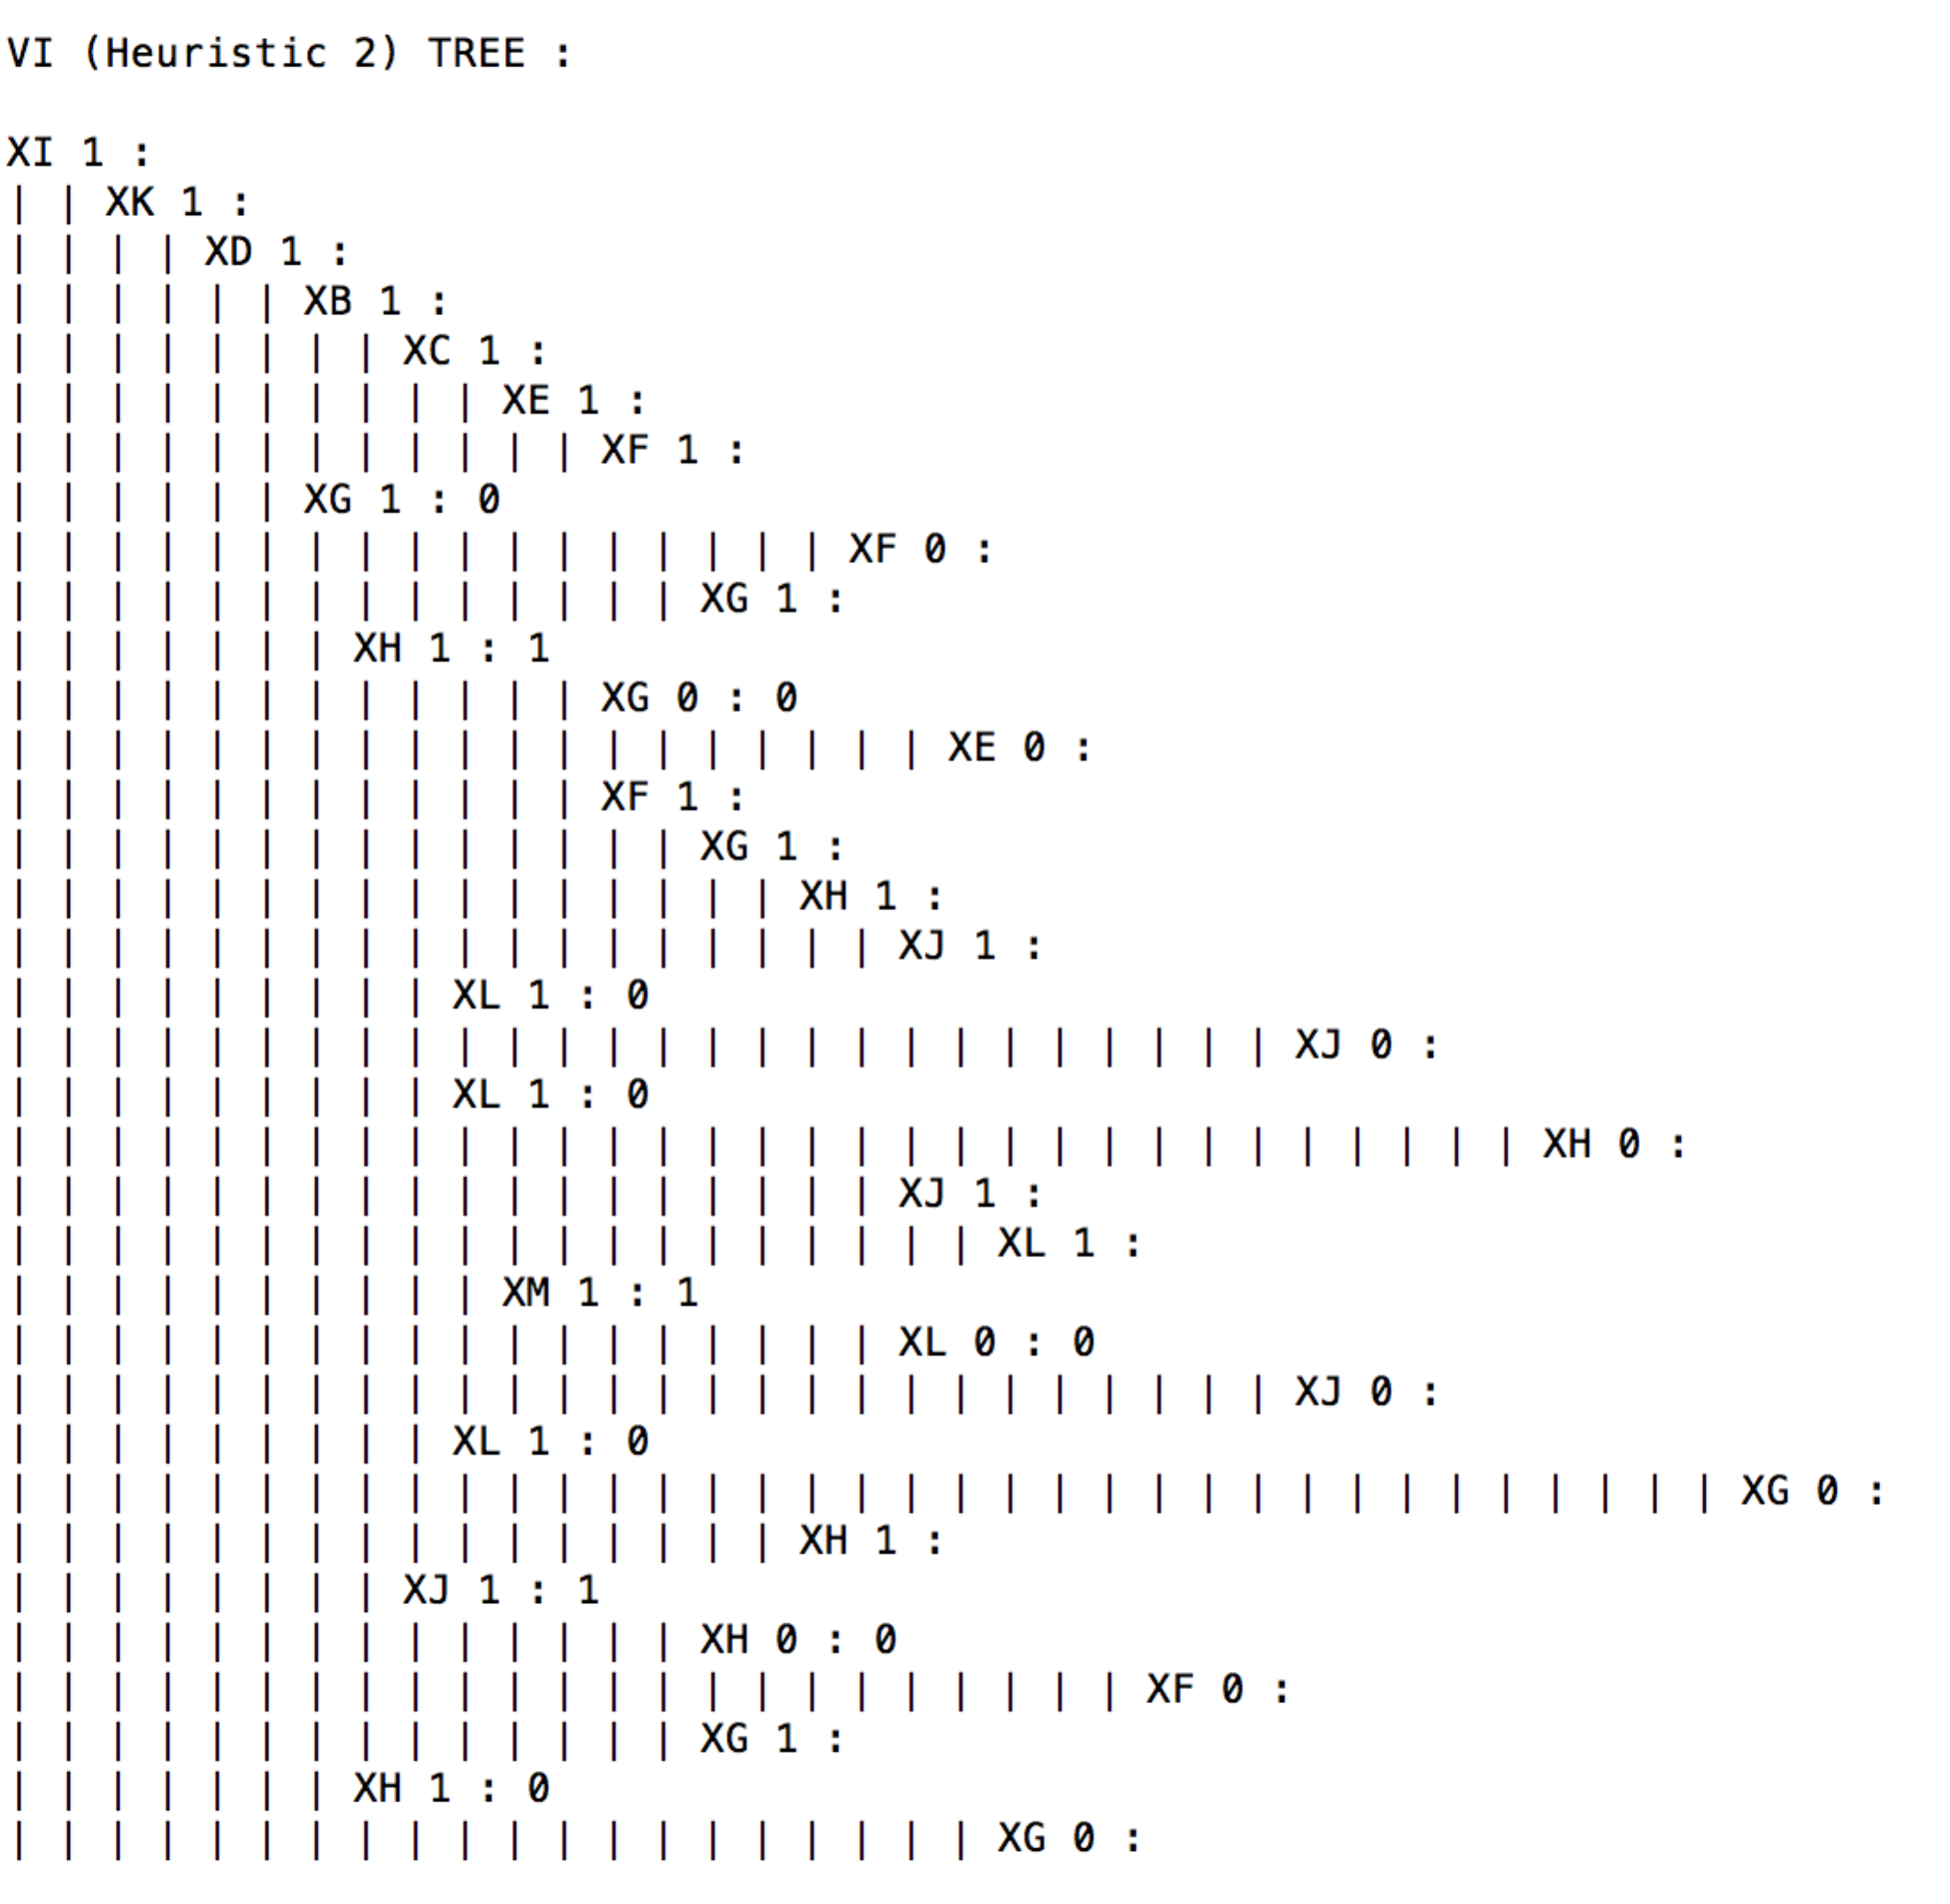

Accuracy: calculated on test data set on the tree, constructed by ID3 algorithm on training data set.

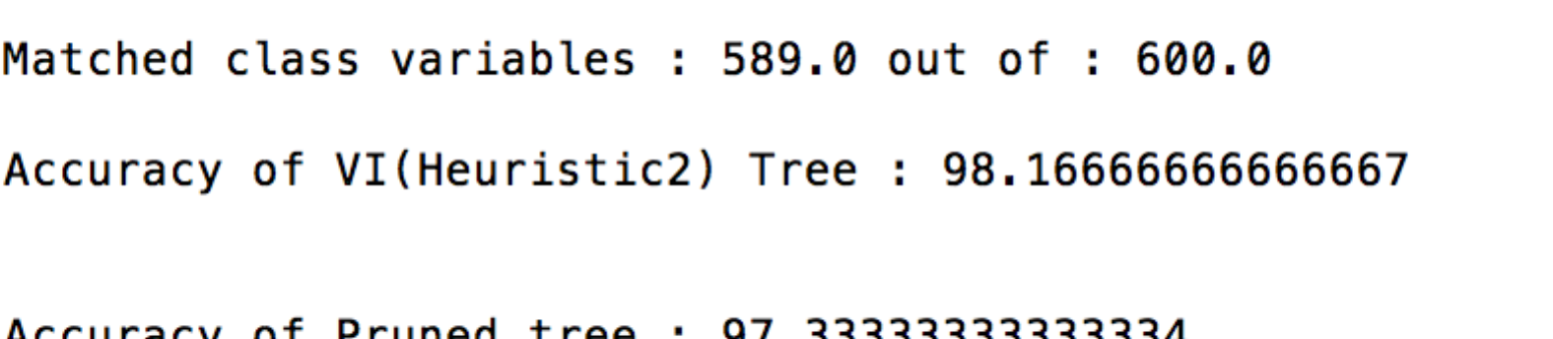

* 1. **Post Pruning**

Tree: Pruned tree on validation data set.

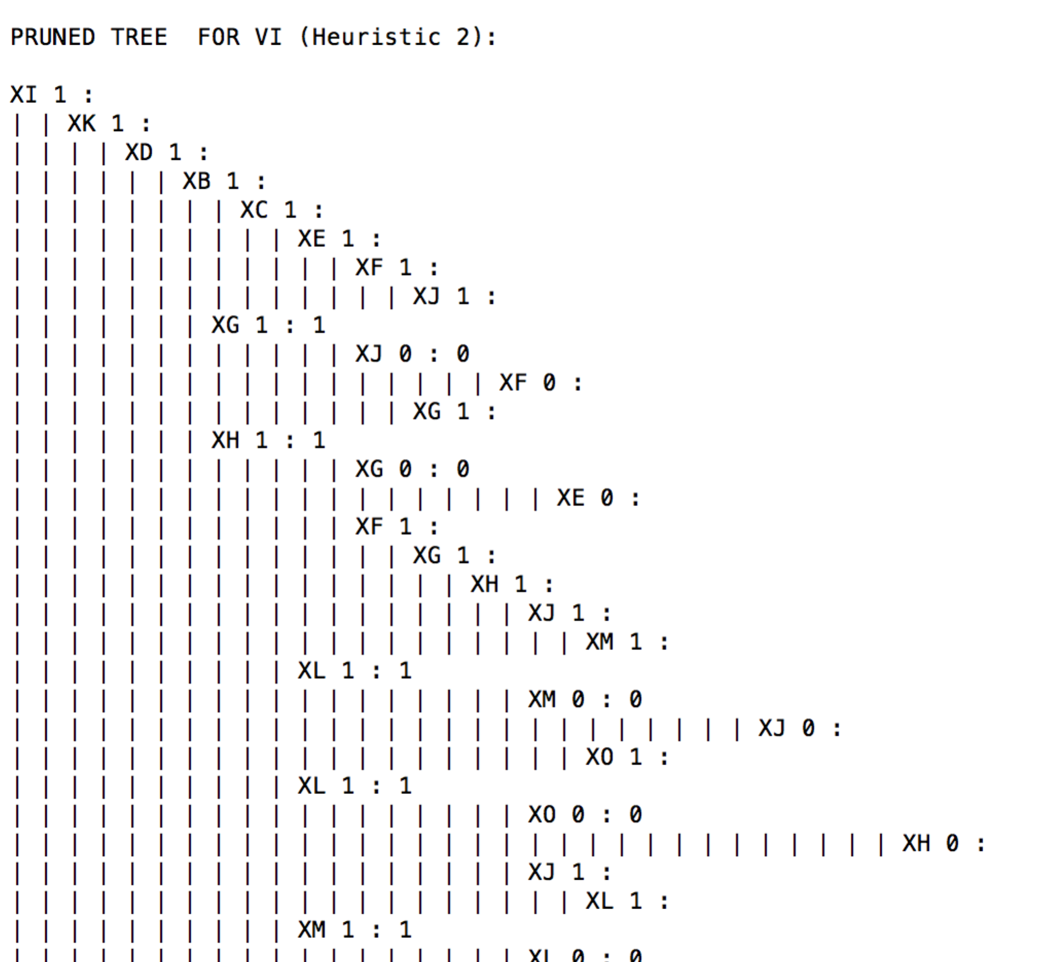

Accuracy: calculated on pruned tree with test data set.

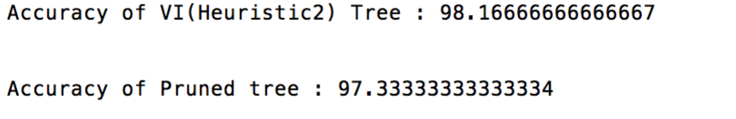

**Example 10:**

With data set 1, accuracy of the tree is for both the heuristics is high. Accuracy even after pruning is reducing. Hence, there is no need to replace the original tree with new pruned tree.

